INOVA WEB APPLICATION TESTING PROCESS AND PAYROLL PROCESS
- COMMON > LOCATION :
I have added the location, and then I will change the modified details: phone number, fax number, and email detail. A sudden message and an error message pop up. (status": "Failed",
"_code": "333",
"_Source": "Post Attachments",
"_Description": "Insertion or update failed...",
"_Details": "DBERROR - 61: Conversion failed when converting from a character string to unique identifier.) )
Status: COMPLETED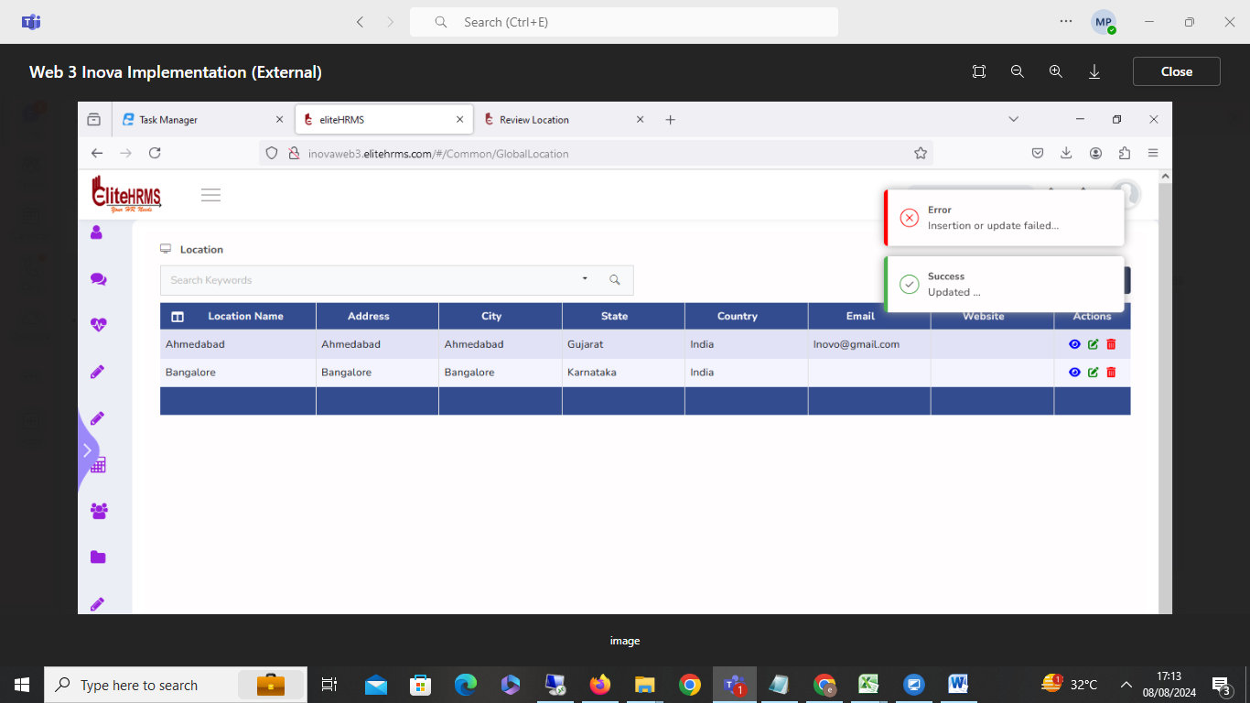

Resolved
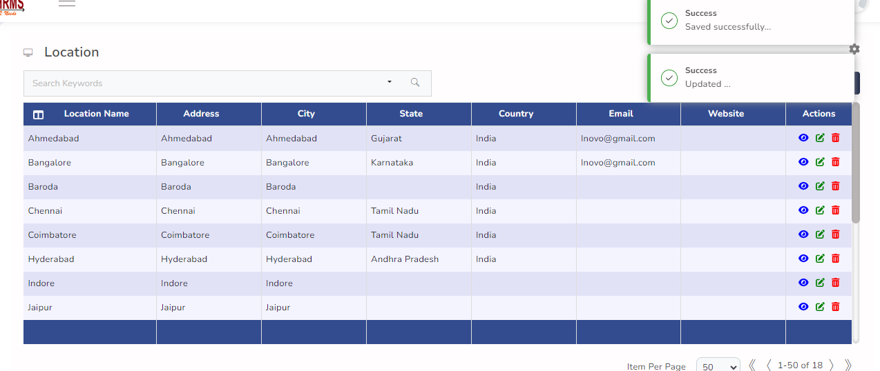

- HR Data> Employee upload

I have tried this employee details upload but error message showed
(_status": "Failed",
"_code": "999",
"_Source": "PostMasterDataUpload",
"_Description": "Exception Occured",
"_Details": "The string 'Devvrat Bani' was not recognized as a valid DateTime. There is an unknown word)
Status: Completed
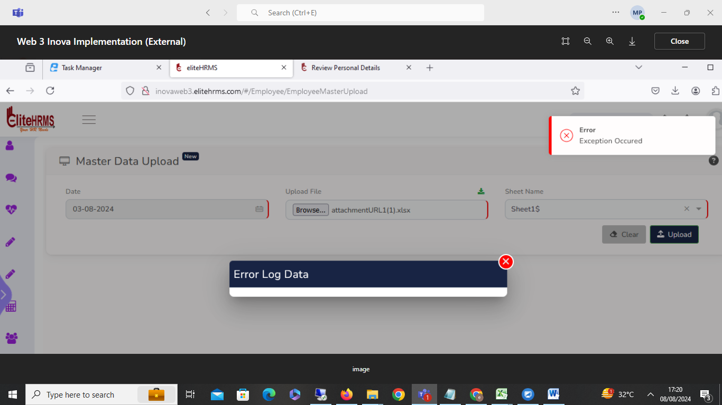

Resolved
Date for DOJ and DOB Should be : DD/MM/YYYY

- Payroll > Pay Master and Rule Builder:

Once company code creation automatically updates the pay element details, some pay element details default to the blank.
Payroll-Pay master and Rule builder screens are only visible when automatically inserting pay element names; the search box is not working; additional added pay element details are not displayed; Status: Completed.

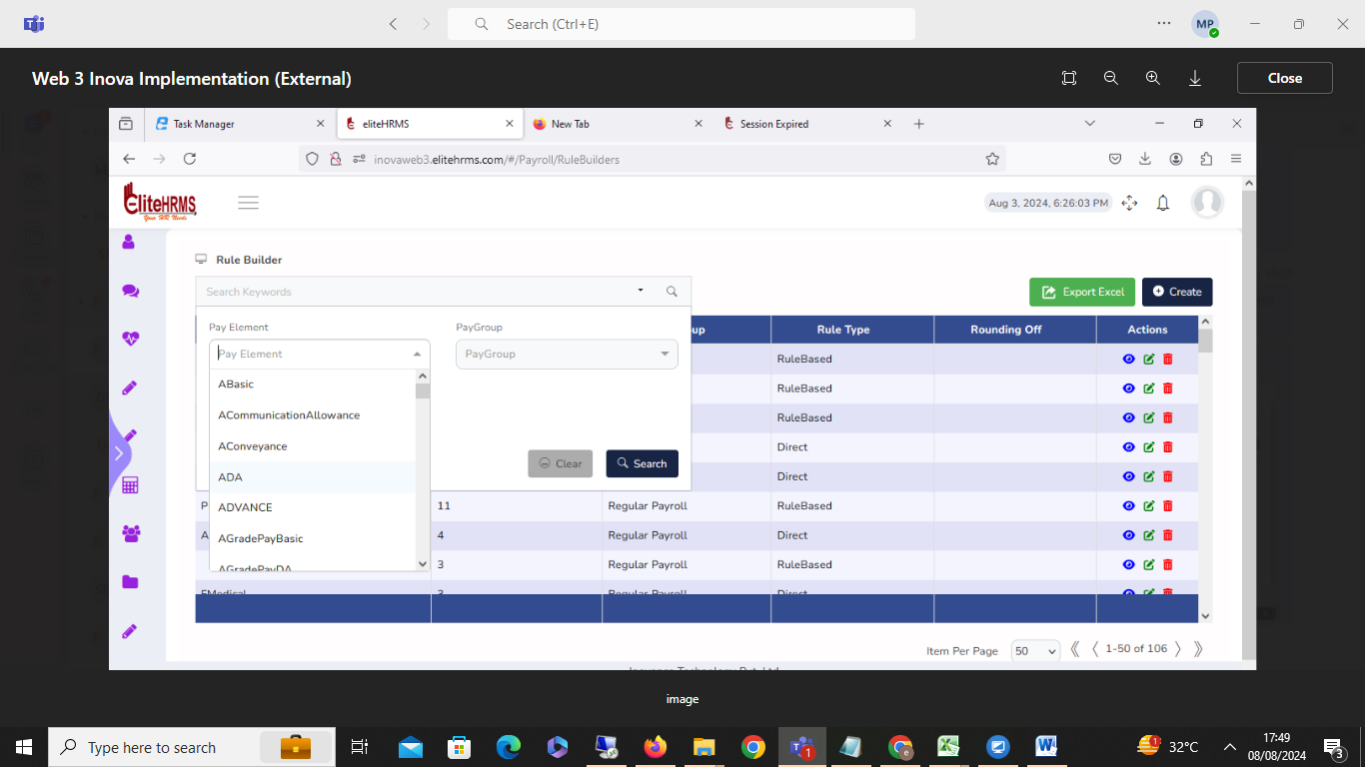

Search Page Pending : Workaround for Logout and Login
4.HR data >Employee update:

The employee master data update screen not working.
Status: Pending
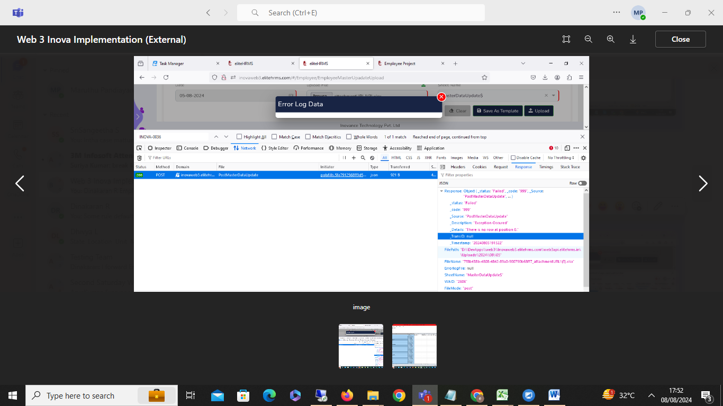

Status: in progresses

- Common > Period:

Period name details are not viewed;
Status: Pending
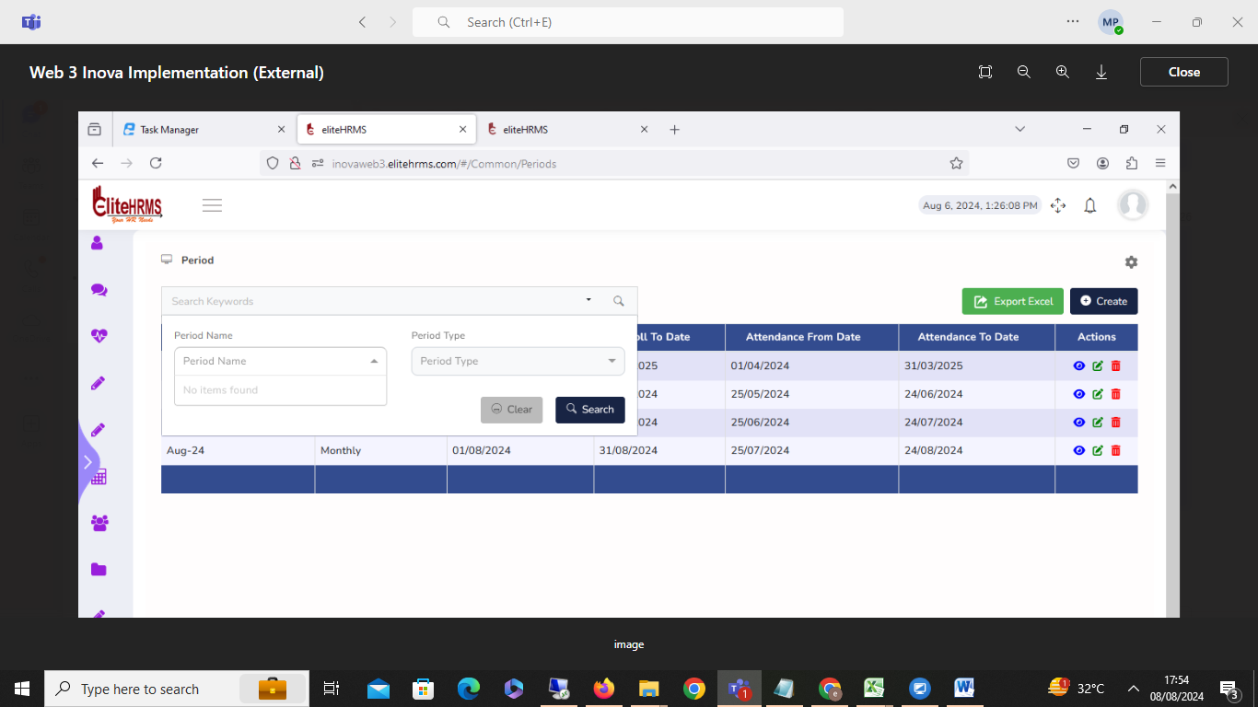
Search page pending

- Payroll > monthly input sheet :

I have downloaded the monthly input sheet for July. The live employee download and resigned employee data are included in the download.
Status: Completed
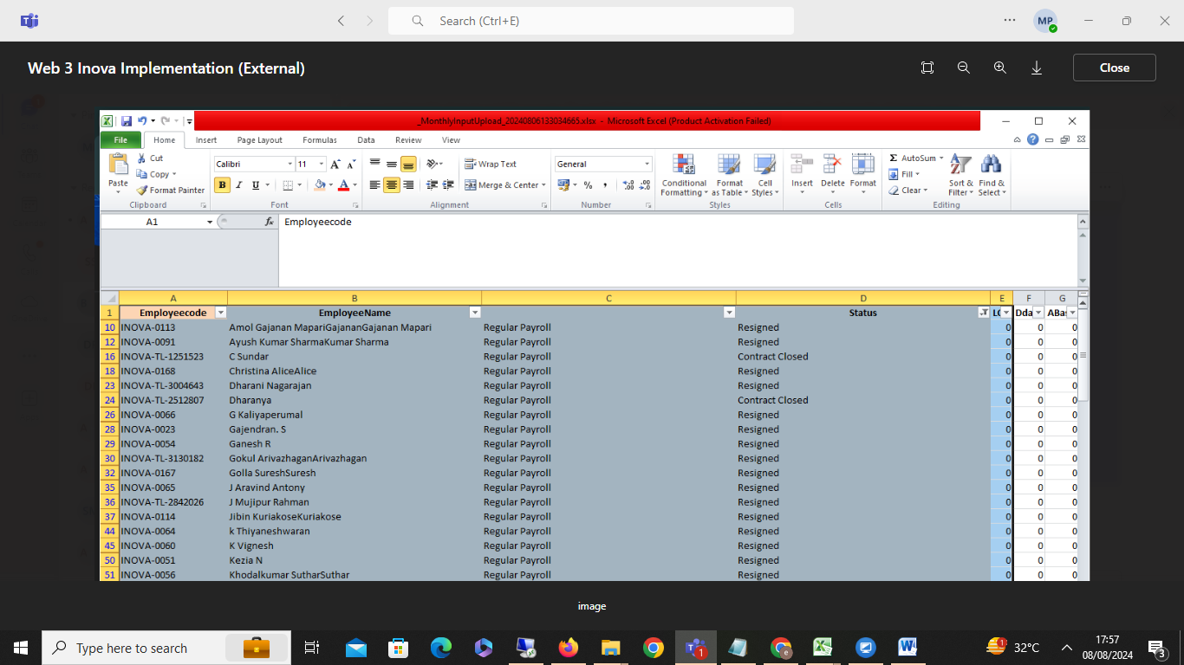

7 .Payroll > Pay element upload:
Status: Completed

I have paid element details uploaded, but data has not been uploaded. Showing the error message (Response": {
"_status": "upload Failed",
"_code": "333",
"_Source": "PostPayelementsUpload",
"_Description": "File uploaded Failed",
"_Details": "DBERROR - Error converting data type nvarchar to numeric. ) 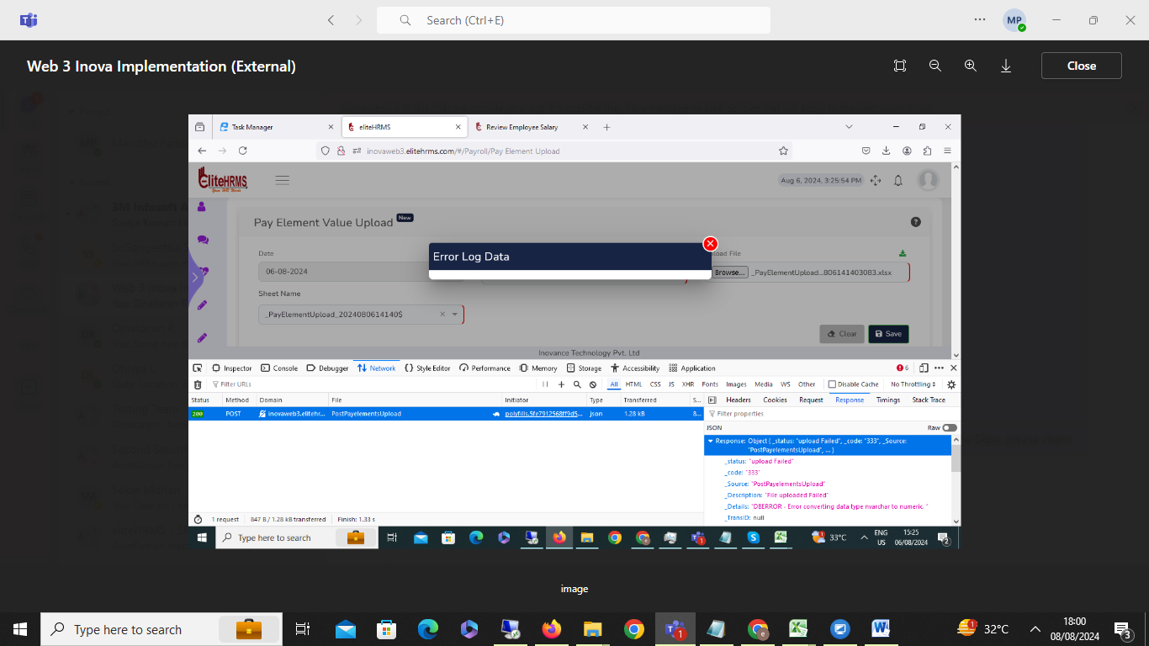

Resolved:
Value should be Numeric Format

- HR data > Employee details :
Status: Pending
The employee details official tab screen ifsc code column record type is not working.
The employee details official tab screen ifsc code column record type issue resolved. Once data is modified and removed, then changed, not saved, please check the issue.

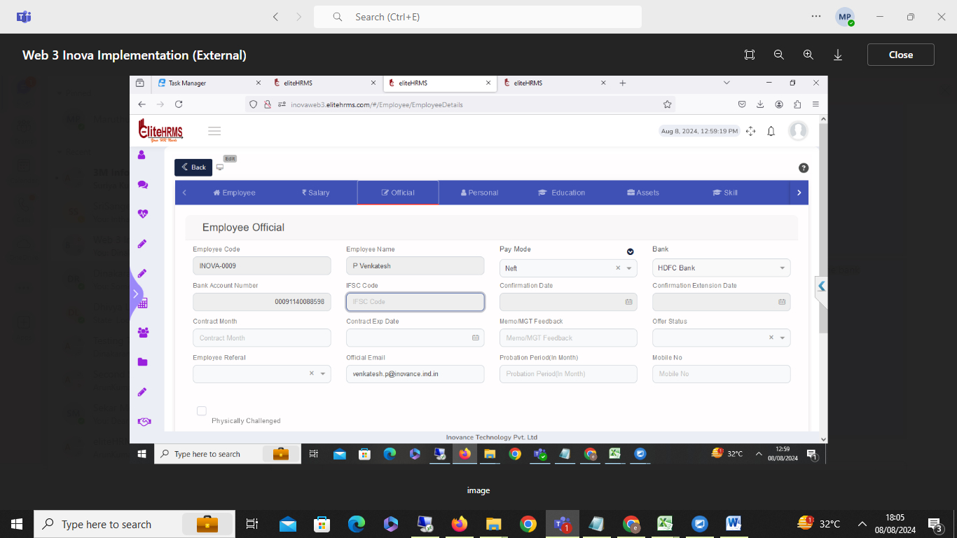

Status: Resolved for Front fix

9. HR data > Employee details :
Status: Completed
I have entered the mobile number, but it displays the error message. The bank account number is already exited.
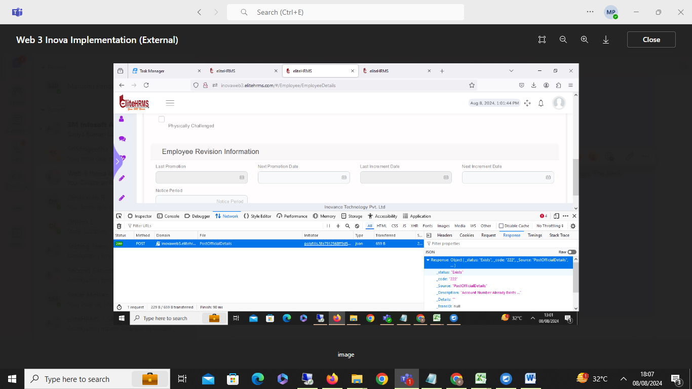

Status: Resolved for Front fix ( Min and Max Length issue )

10. Hr data > Employee details :
I have added the education tab in family details, but it has been shown as an error. Message, Status: Pending
Response": {
"_status": "Failed",
"_code": "999",
"_Source": "PostEducationDetails",
"_Description": "Exception Occured",
"_Details": "Index was out of range. Must be non-negative and less than the size of the collection. (Parameter 'index')",
"_TransID": null,
"_Timestamp": "20240808133009"
},
"EducationDetails": [],
"FamilyDetails": [],
"Separation": []
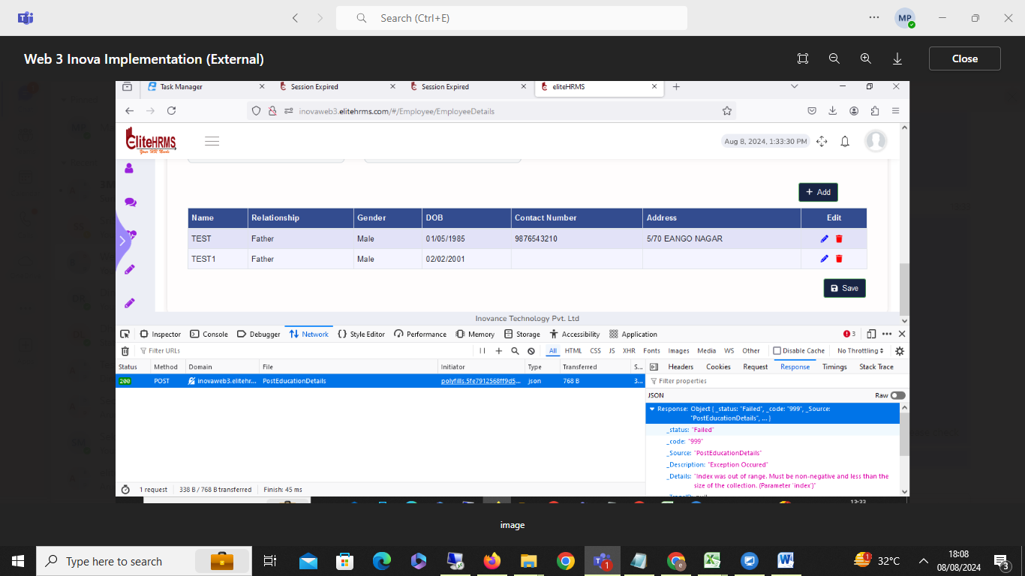

11. Hr data > Employee details :

Employee details The Assets tab details delete options are not working. Please check the error message.

Status: Pending

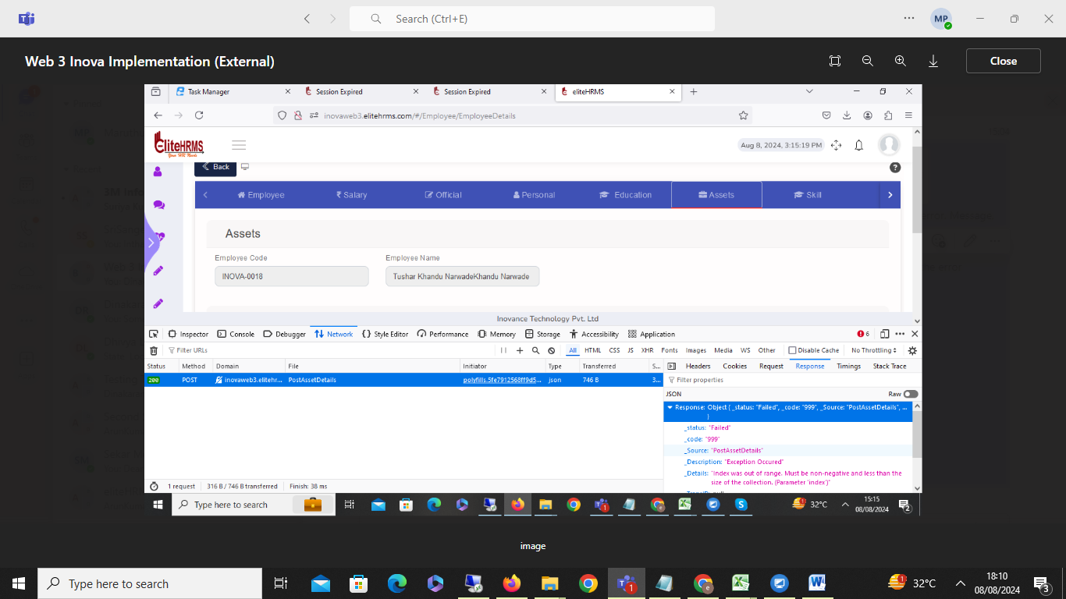

12. HR data > Employee details:

Employee detail - Employee skill screen add details successfully message show, but problem is once record delete and save button click error message display please check the issue
Status: Pending
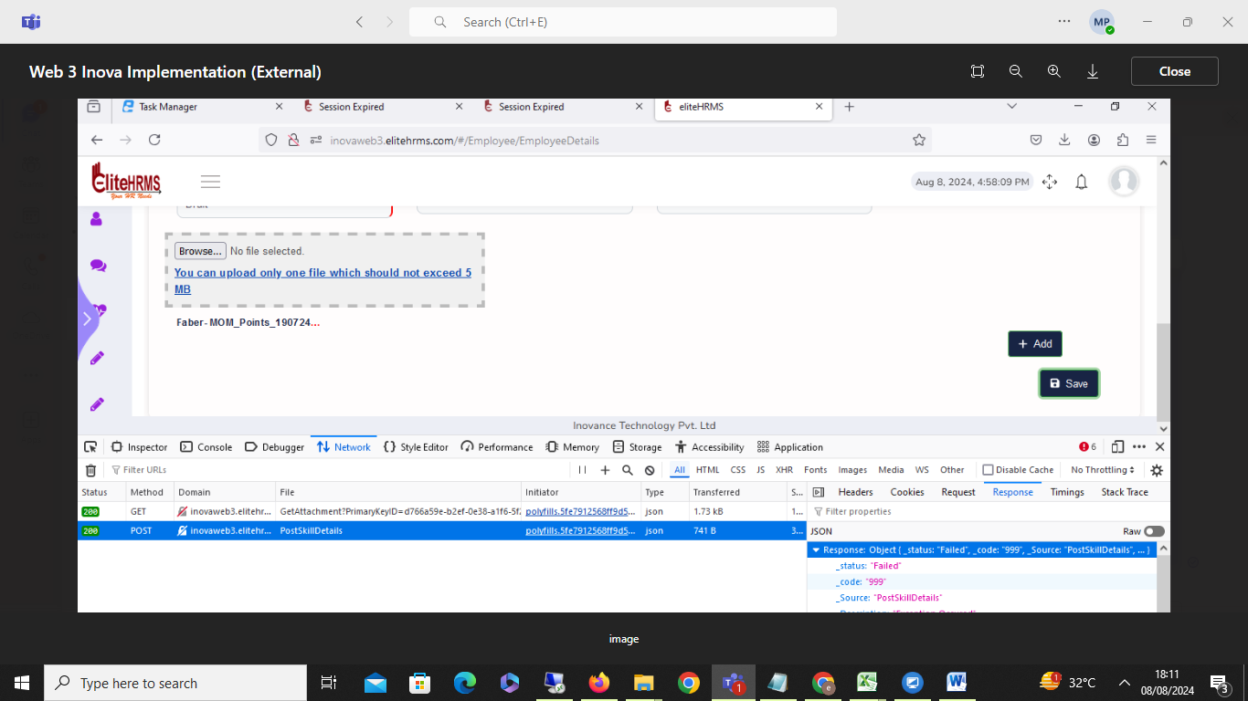

13. HR data > Employee details:
Status: Completed

Employee detail: Employee statutory details screen P and esi details modified to the save button The click-but-save button is not working. The problem is a number character issue.

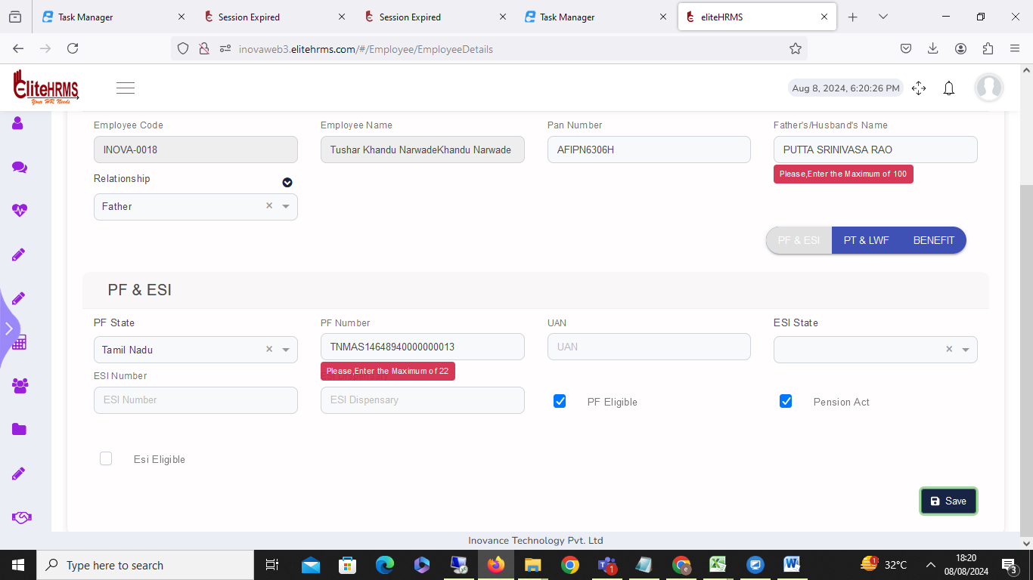

- Payroll > monthly input sheet :

The monthly in-put data upload format is working fine, but the problem is that the previous month's upload data is not being downloaded to the Excel sheet
Status: Completed

- HR data > Employee details :
Status:Pending
The employee details official tab screen contract Month first added then month column clear but default Contract date showing. 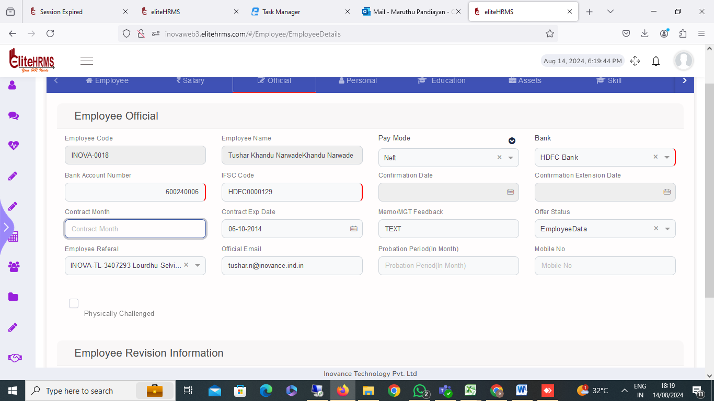
16. Common>Role
Please review and explain the role screen's addition of the DashBoard Item details Mandatory.
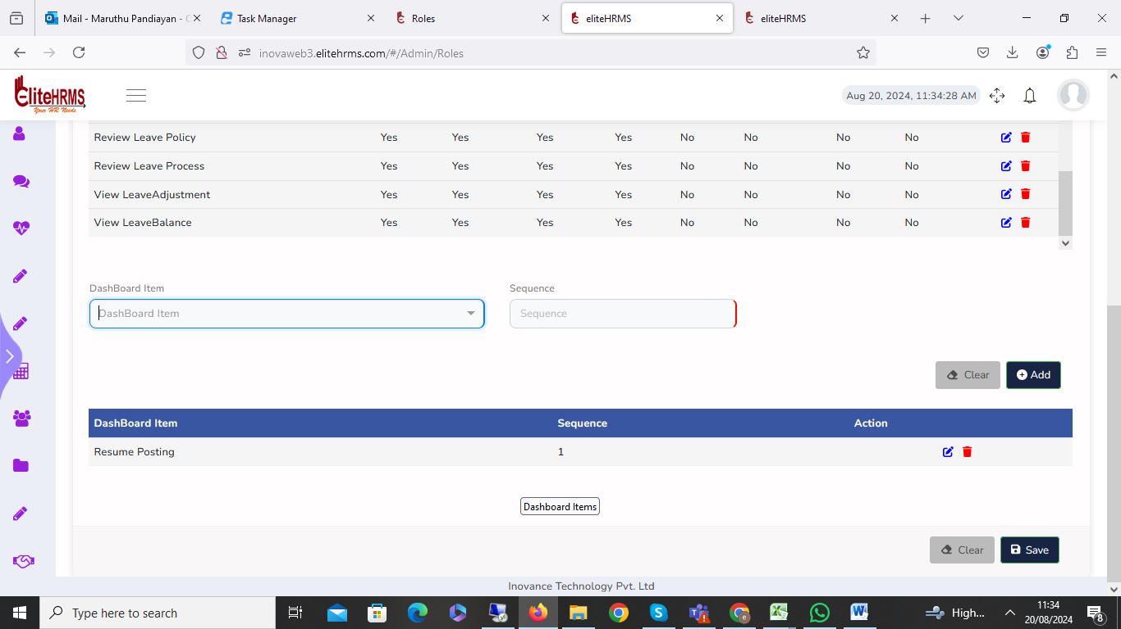

17.Admin>MailTemplates
The mail template screen details are not visible. Please check.

Status: Completed

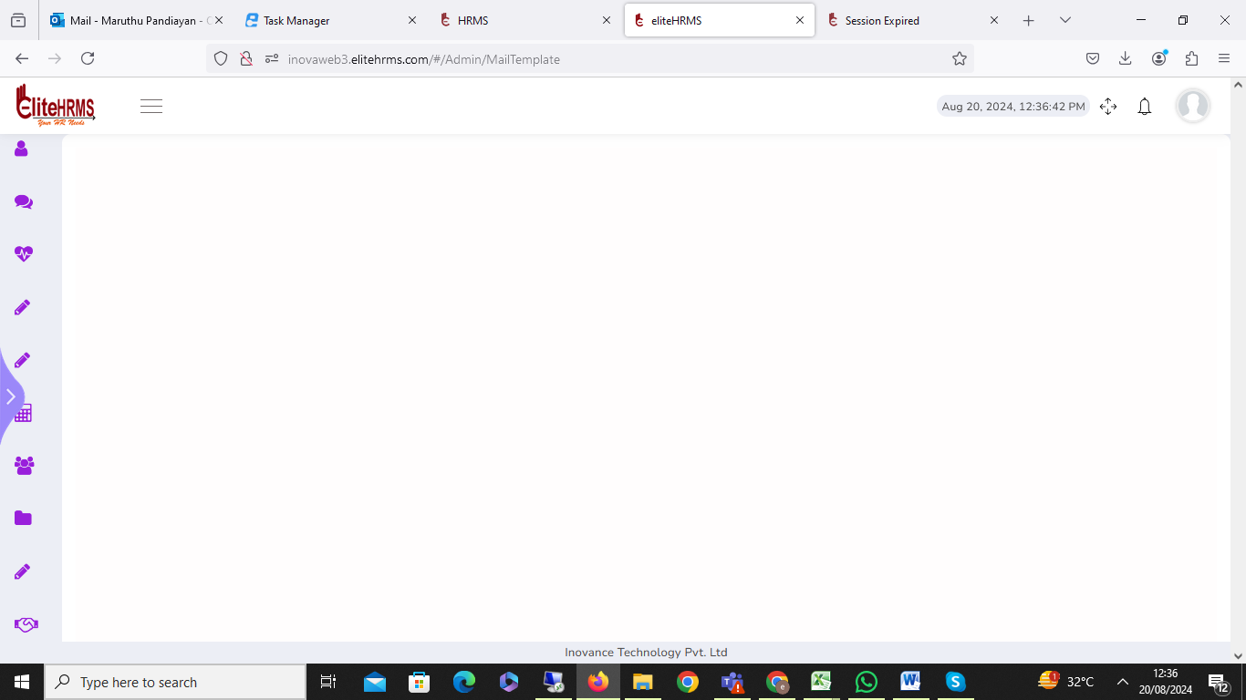
18. Admin>Trigger Template

Once the trigger template screen is clicked, the application automatically logs out and logins to the page. Please check the issue.

19. Common>Period

The period problem is that I have selected a future date from the date select automatically future end date view. The system visible is the current month date.

Status: Pending

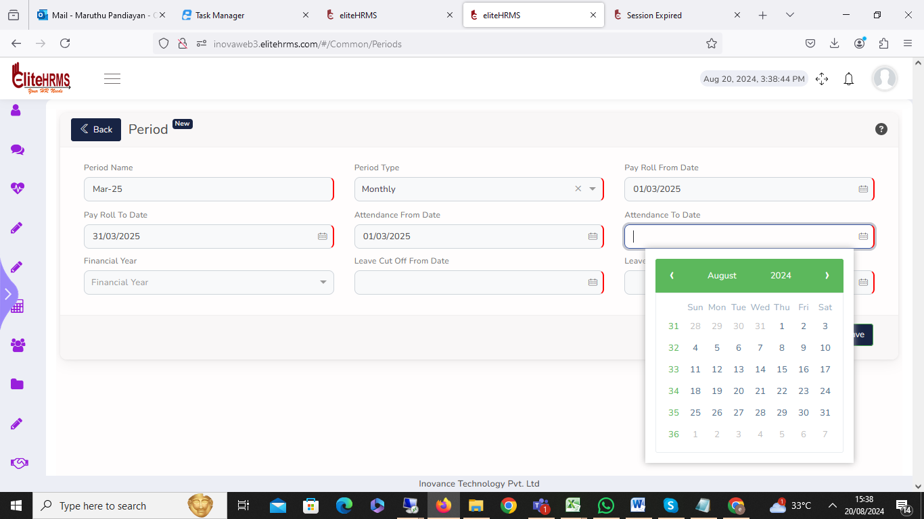

20. Common>Structure

First-time employee detail upload department details automatically update but empty record also insert. I have deleted the empty record showing the error message. Please check.

Status: Pending
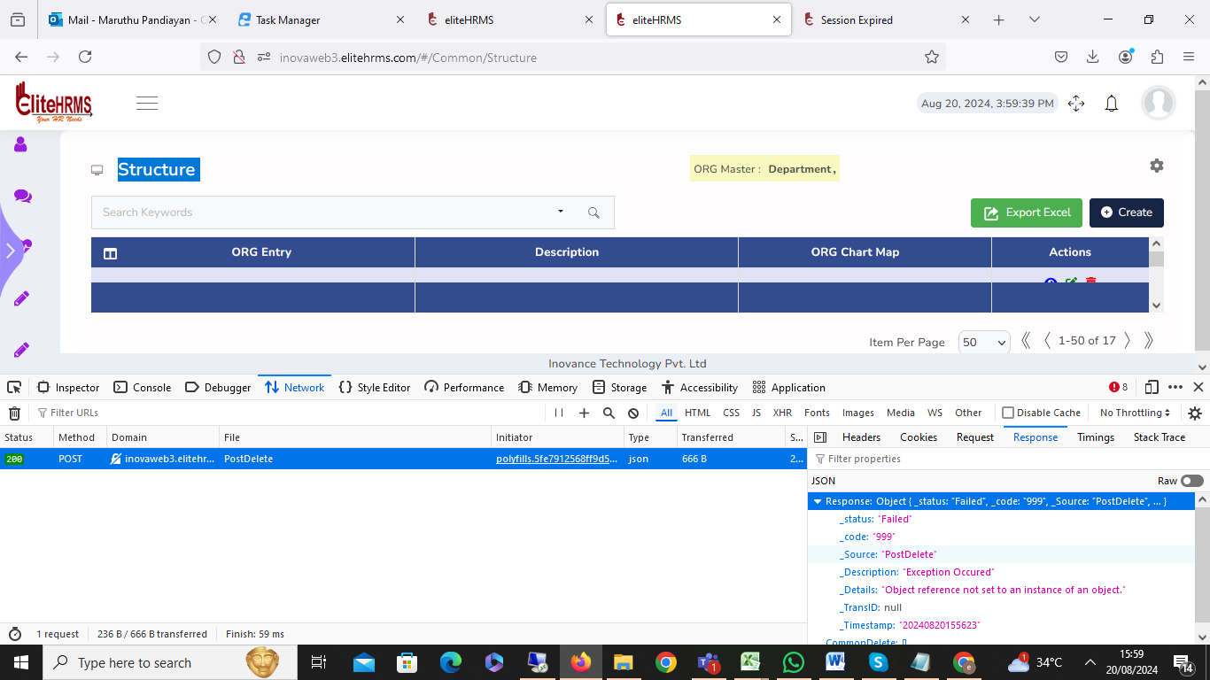

21. Common>Location:

Location data have been added, but the logo picture has updated automatically. Please verify.

Status:Pending

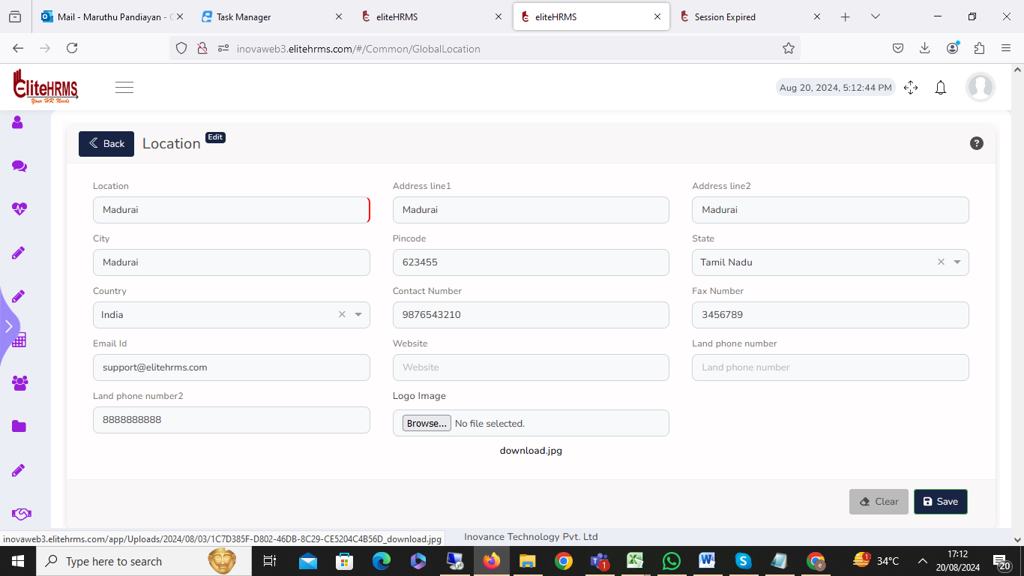
22. Common>Interview list

The interview details edit button clicks, but details are showing for the blank.

Status:pending

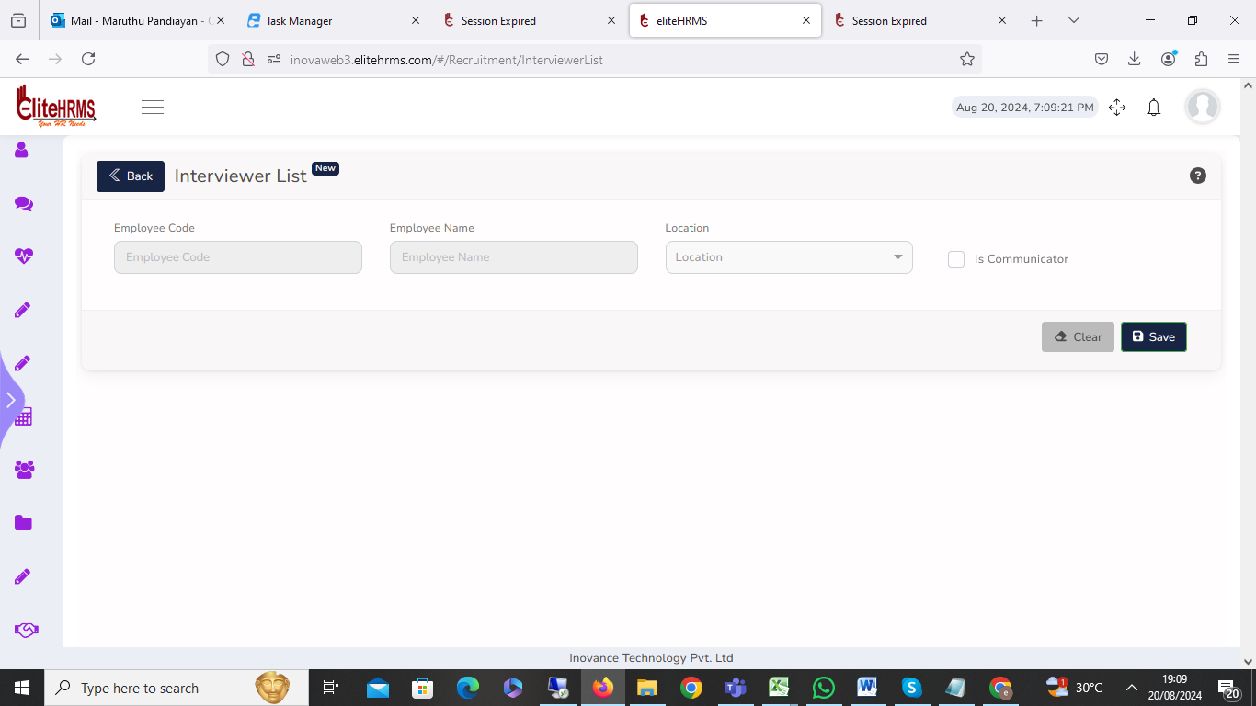

23.Common>Question

I have added the question, and the answer is working fine. but the option value is only a number; an alphanumeric value is not allowed. My suggestion is that alphanumeric is allowed.
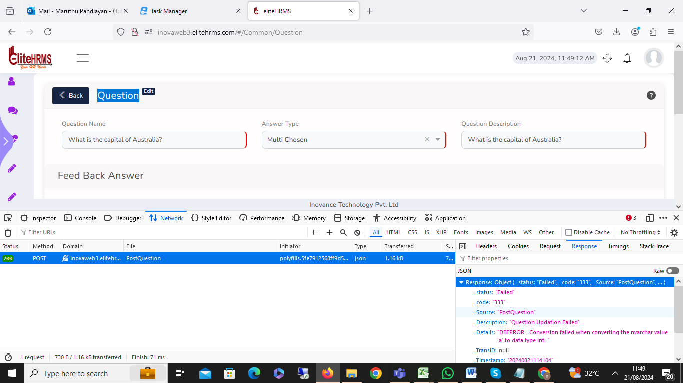

24.Common> Survey Creation > Employee Selection:

The Survey Creation Employee Selection tab division tab filler is not working.

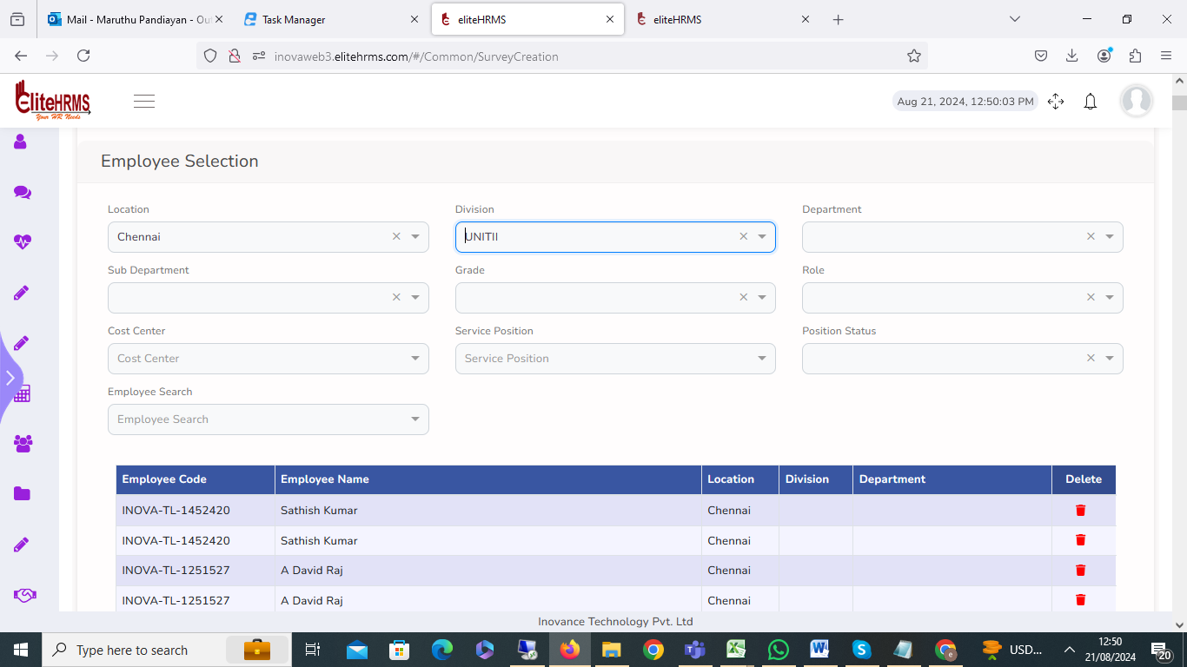

25.Common> Survey Creation > Employee Selection:

The Survey Creation Employee Service Position and Position Filter option clicked, but an error message was showing. Please check.

Status: Pending
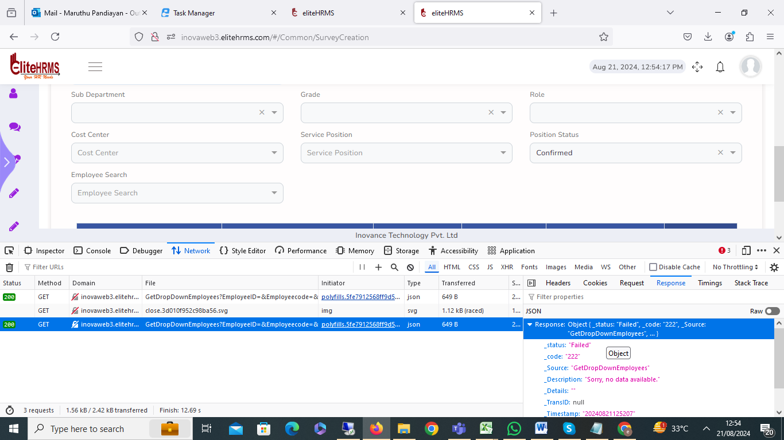
26.Common> Survey Creation > Employee Selection:

The all-details entry finally saved, but on clicking show an error message, please check.

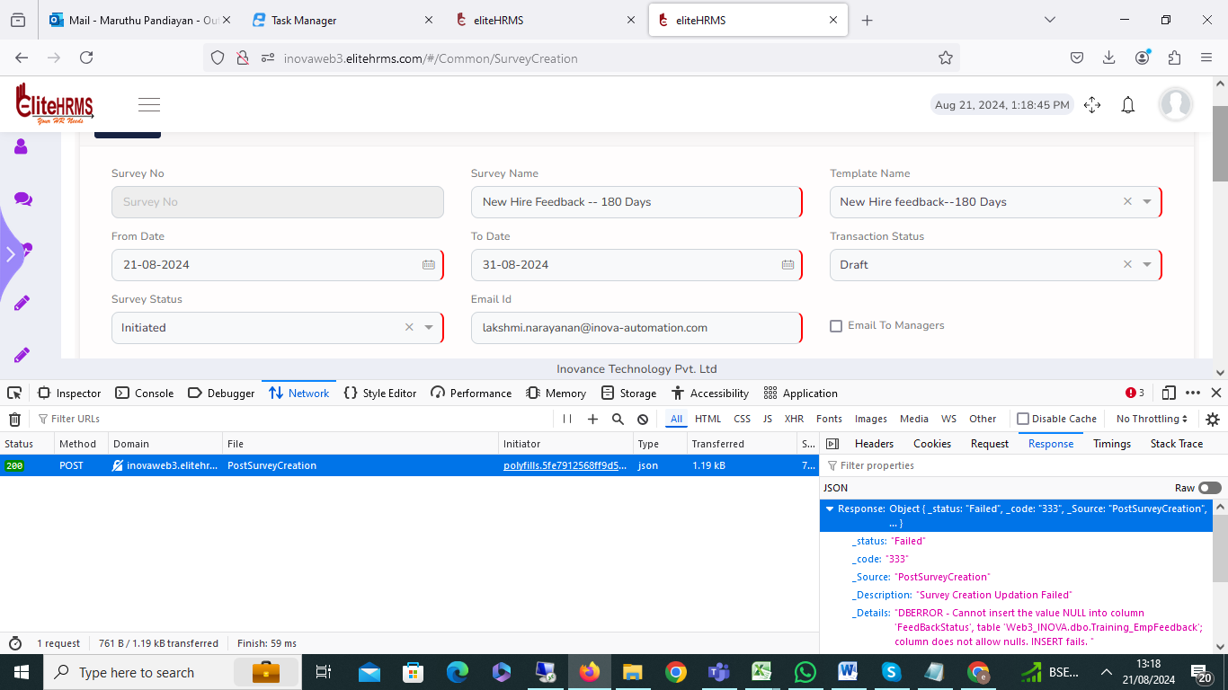

27. Common>Policy Template:
Policy Template record was added, but once the edit button was clicked, the data was not visible. Please check.
Status: Pending

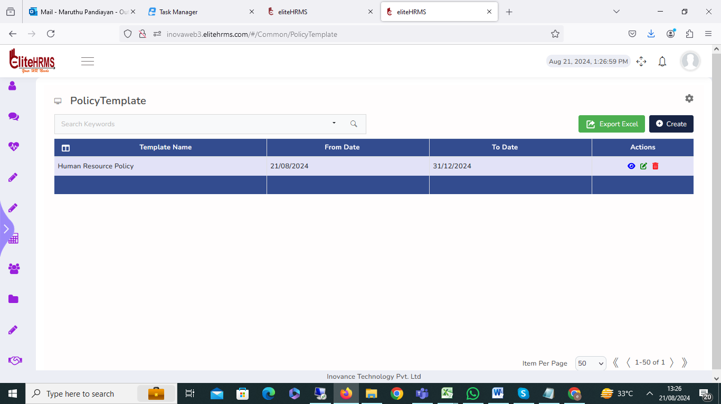

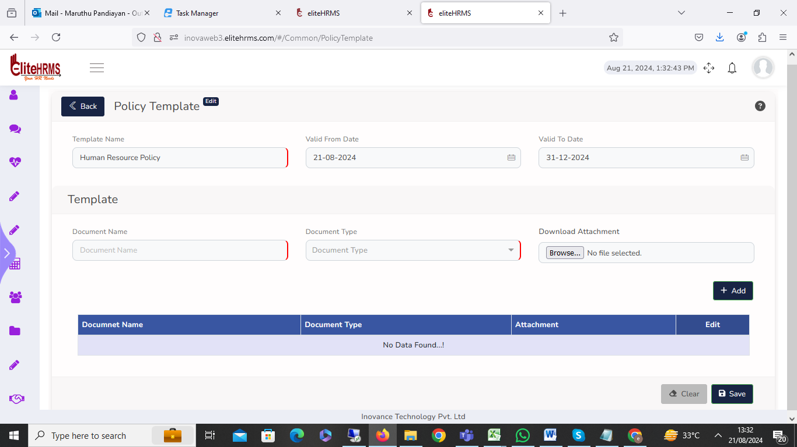

28. Infra Department:

I have created the infra department. No issue, my question is: one department multiple request type role added one record edit changed the department all data department changed, please explain the process.
Status: Pending
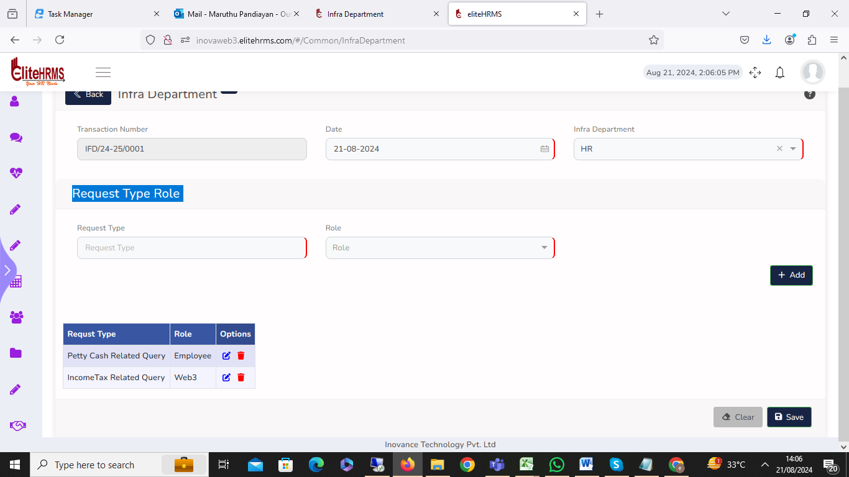

29. Review Location
Review location filler options are not working; please check.
Status: Completed
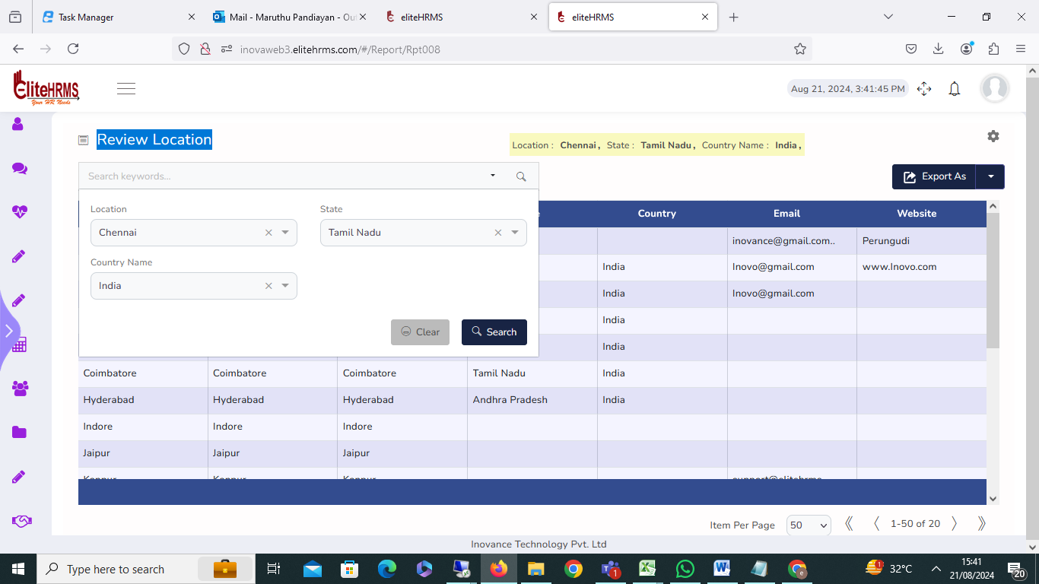

30. Review User

Review User filler options are not working; please check.
Status: Completed

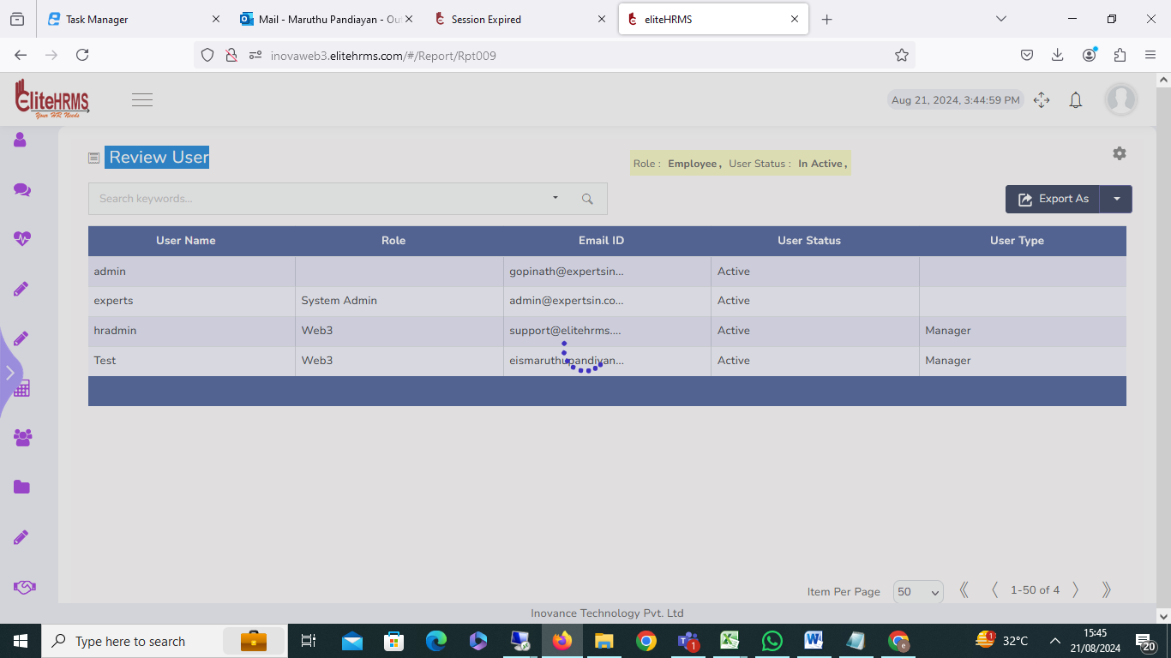

31. Geo Fencing:

On the geo-fencing screen, all details are blank, and add a button to the showing error.

Status:Pending

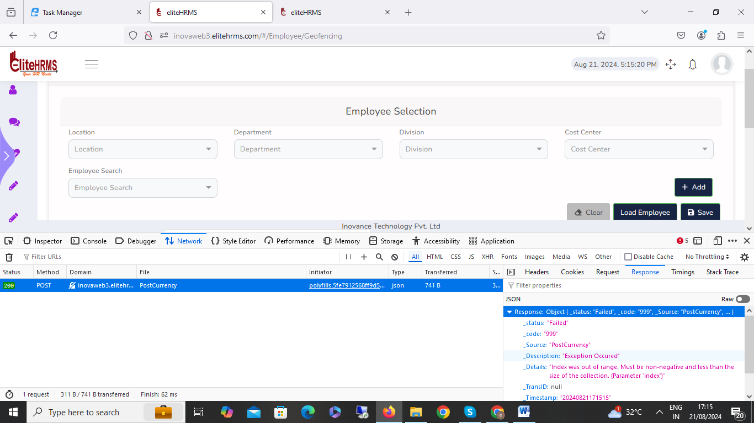

32.Hr Data Dashboard:
Once the dashboard screen is clicked, the application automatically logs out and logins to the page. Please check the issue.

Status: Pending

33. Review Employee Details

The review Employee details screen Service Position off role details not available once available on role search filter working after changed same details visible filler is not properly working. Please check.

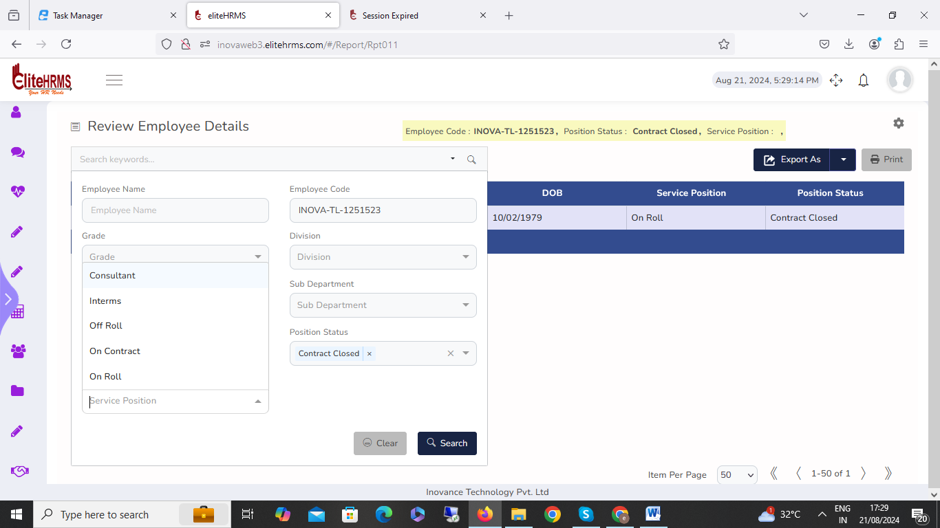
Ststus:Completed
34. Review Employee Officials:
The review Employee Officials screen Service Position off role details not available once available on role search filter working after changed same details visible filler is not properly working. Please check.
Ststus:Completed

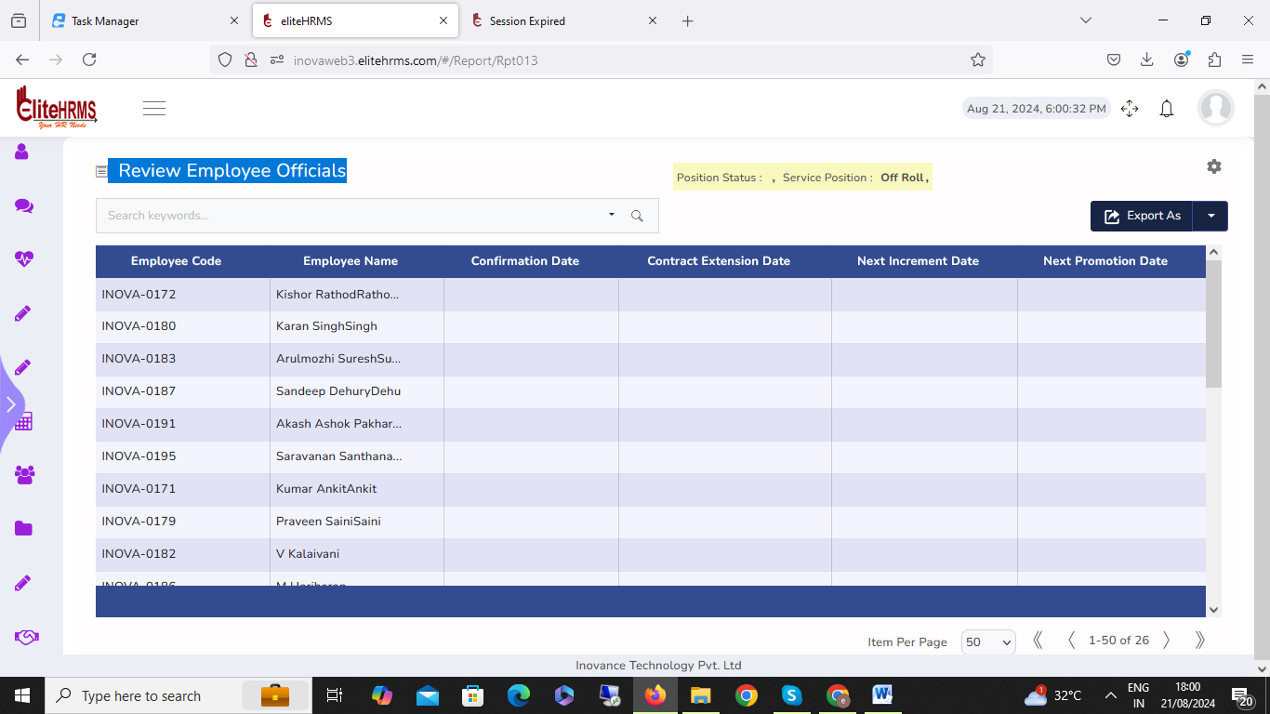

35 . Review Employee visa details:
The review Employee Officials screen Service Position off role details not available once available on role search filter working after changed same details visible filler is not properly working. Please check.
Status: Completed

36. Review Statutory
The review Employee visa screen Service Position off role details not available once available on role search filter working after changed same details visible filler is not properly working. Please check.
Status: Completed

37. Review Education Details
1. The review Employee Education screen Service Position off role details not available once available on role search filter working after changed same details visible filler is not properly working. Please check.

2. The Review Education Details degree detail has multiple selected options, but multiple filler options are not working. Please check.
Status: Completed

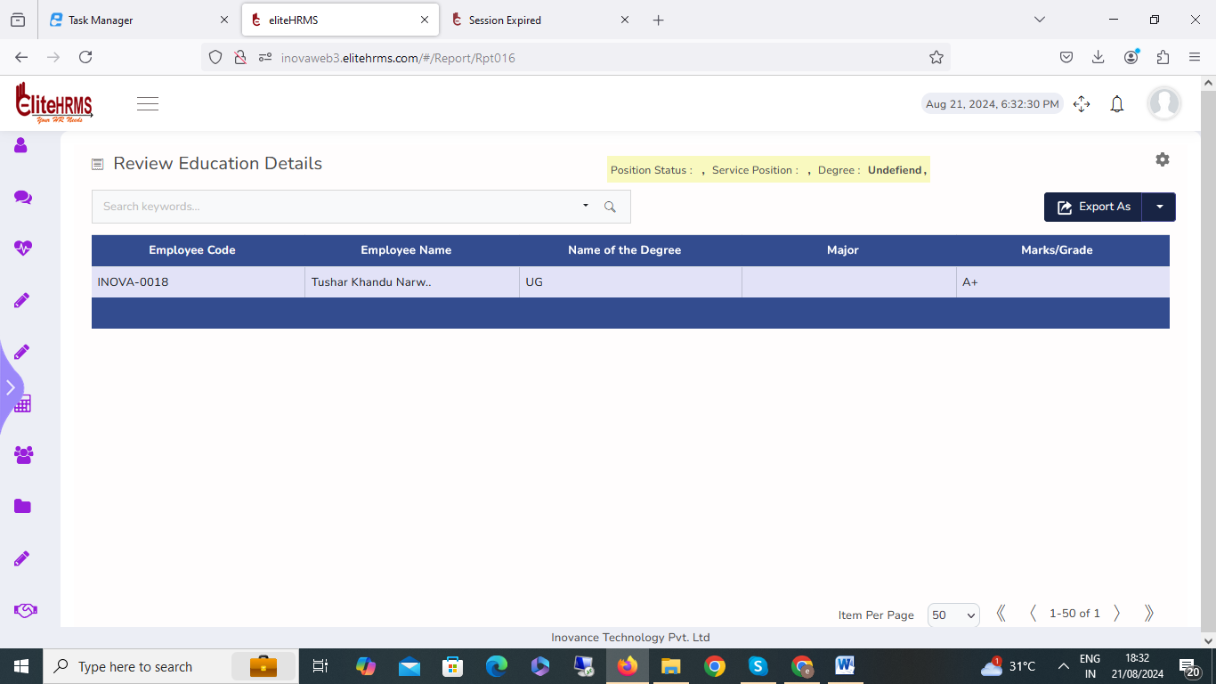

38. Employee Awards:
The error message now displays the award details that were added, saved, and displayed.
Status: Completed
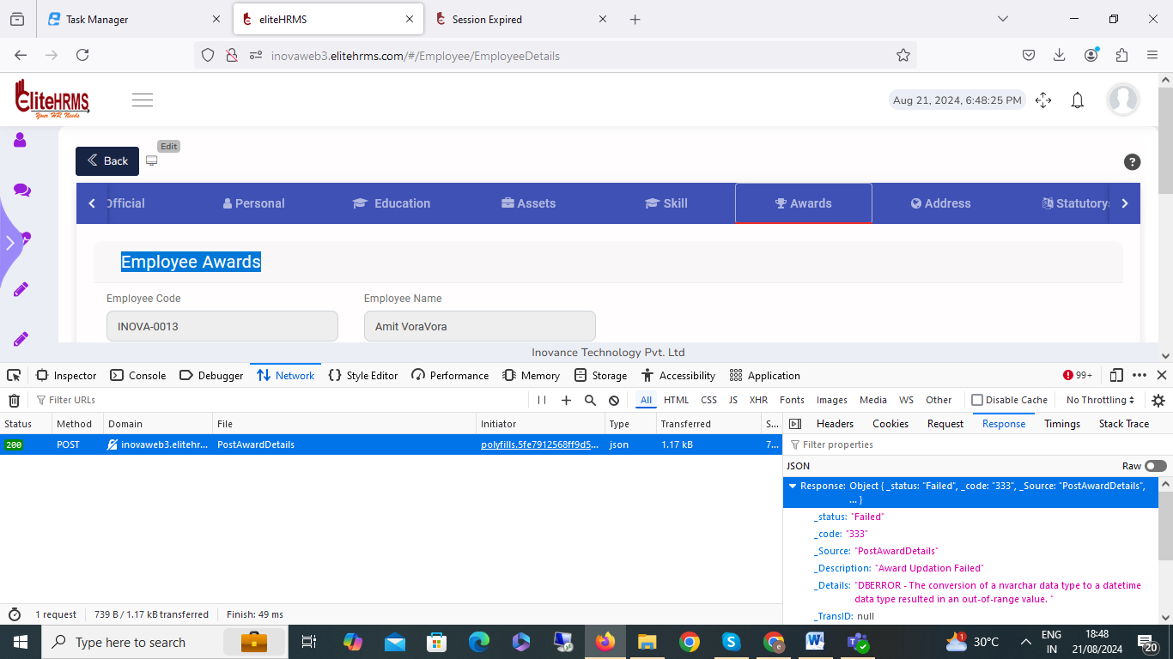

39. HR Analytics
The HR Analytics screen details the multiple fields selected. I have clicked Save Template Options to display an error message for the already record exists.
Status: Pending

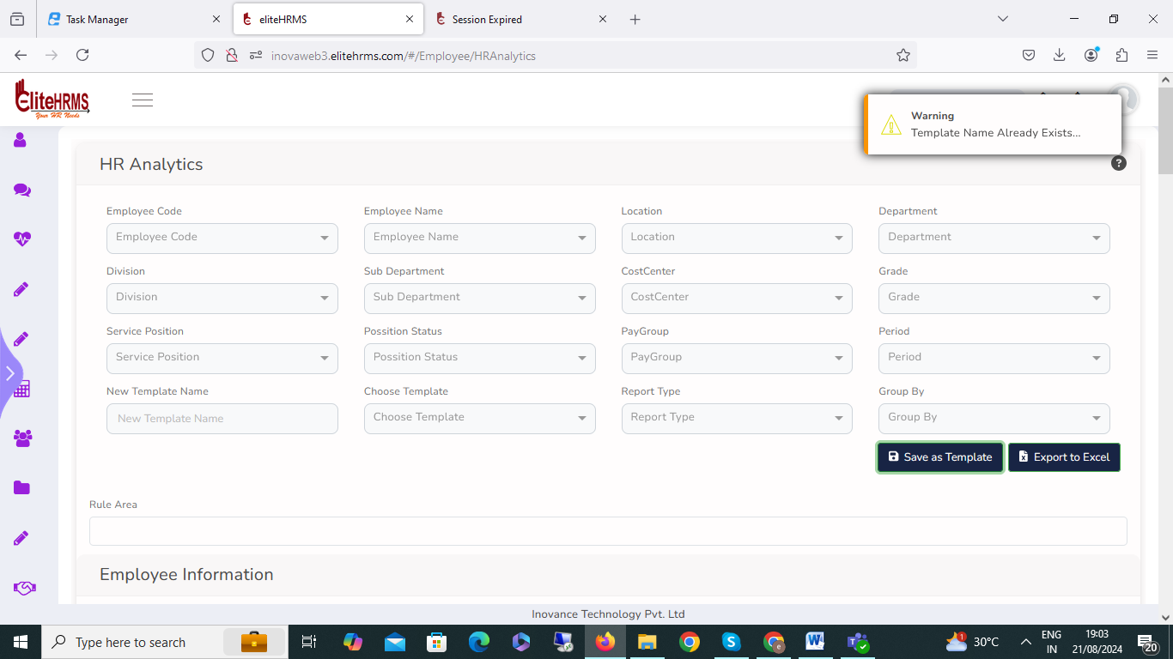

40. Review Aging Report

Once the Review Aging Report screen is clicked, the application automatically logs out and logins to the page. Please check the issue.

41. Review Employee Salary

Review the employee salary report. Select column details that are not visible. Please check the issue.
Status: Pending

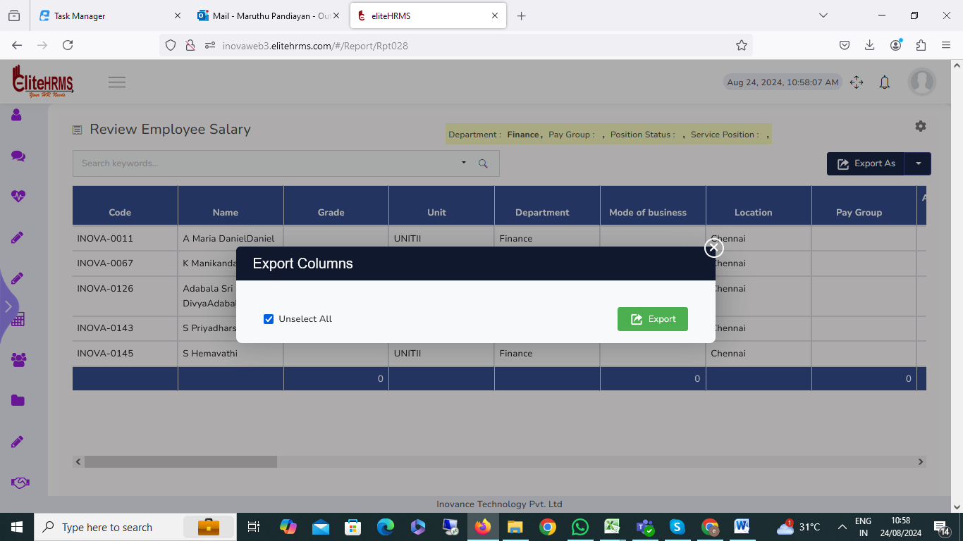
42. Review Experience Report

Review the Review Experience Report . Employee name filter options that are not working. Please check the issue.
Status: Pending

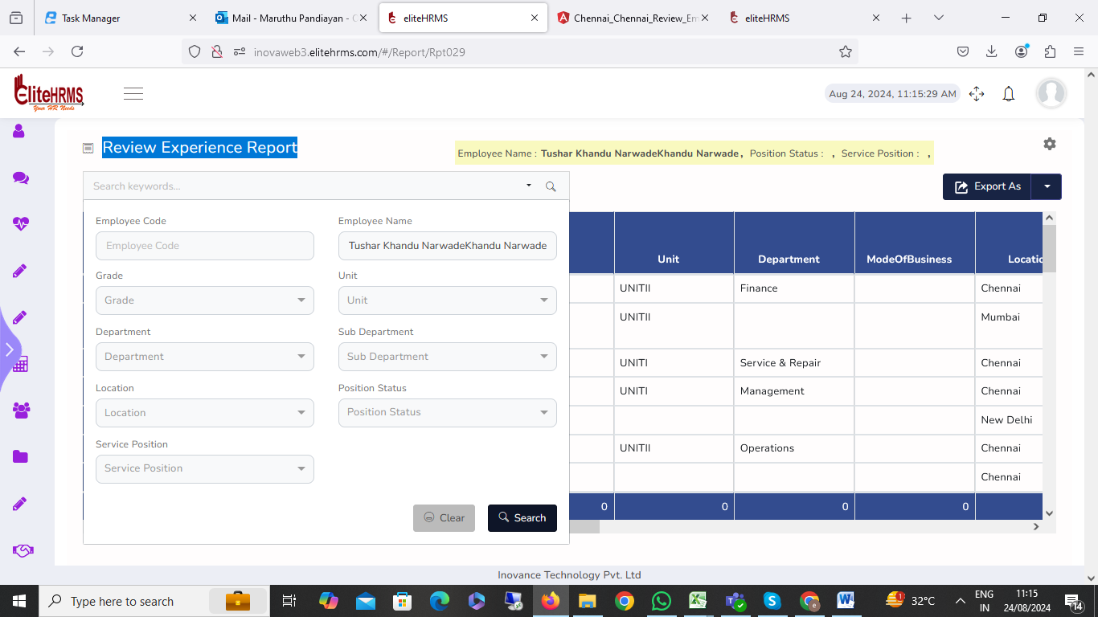

43. Review Experience Report
Review the Review Experience Report. Select column details that are not visible. Please check the issue. Status: Pending

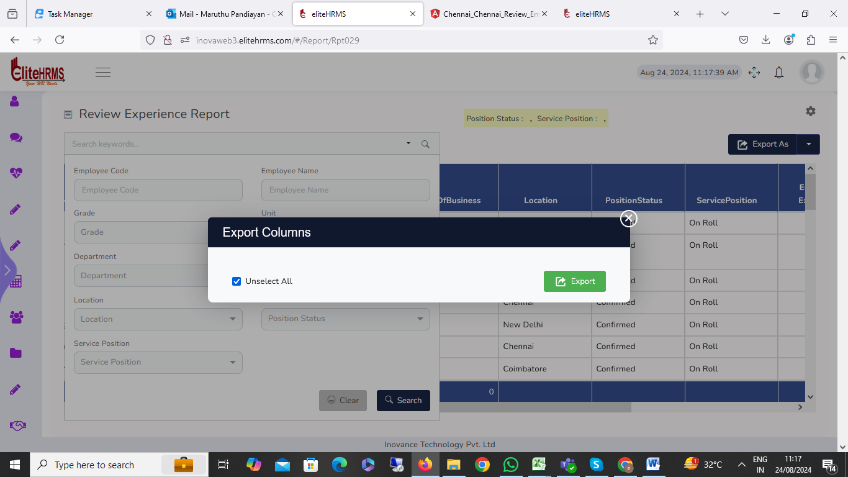
44. Job Offer
I have checked the job offer entry details data satisfactory message, but the problem is the letter-generated options click showing for the error message. Please check
Status: Pending

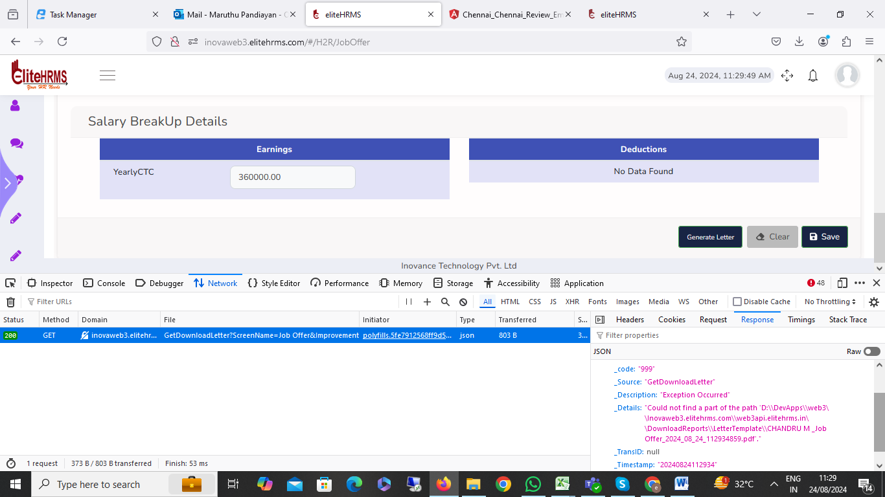

45. Increment
I have one entry in the increment details record added, no issue. Once the record is finalized for the automatic salary change, I try to have the August month payroll process completed. but employee salary has not changed; please check the issue.
Status: Pending

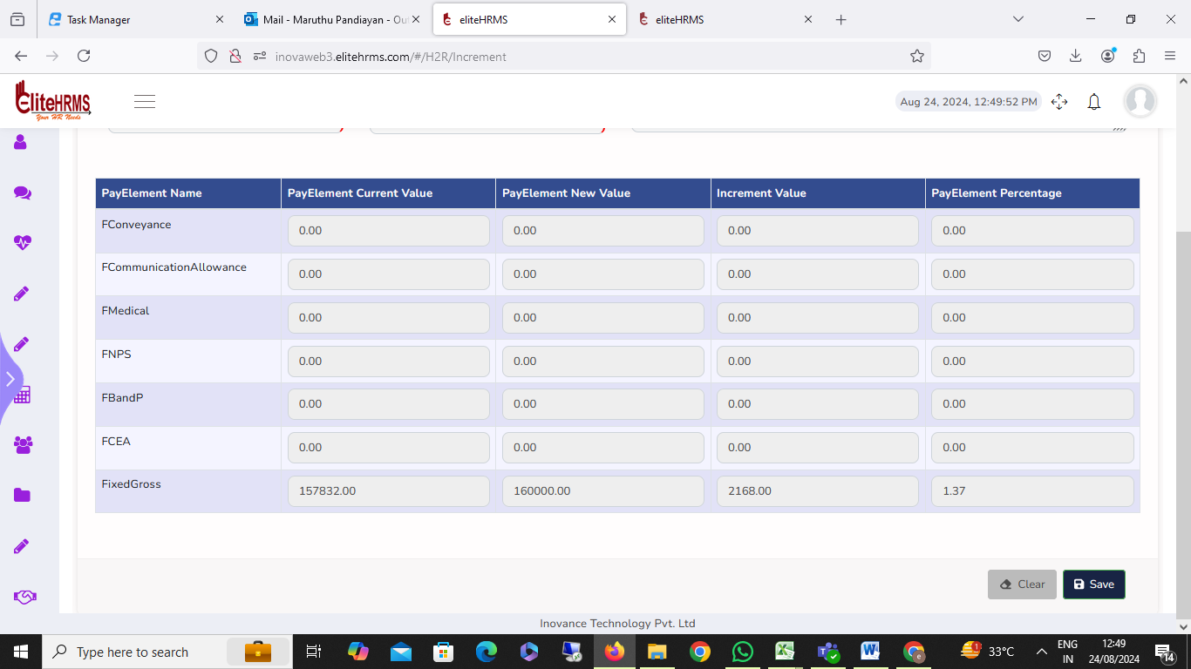
46. Increment:
I have checked the increment entry details data satisfactory message, but the problem is the letter-generated options click showing for the error message. Please check

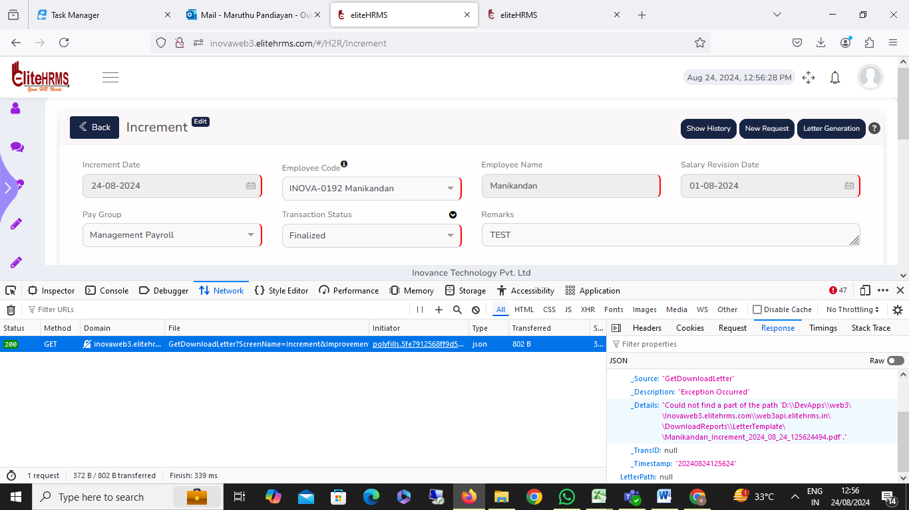

47. Increment:
Show history and New Requested button not working, Please check

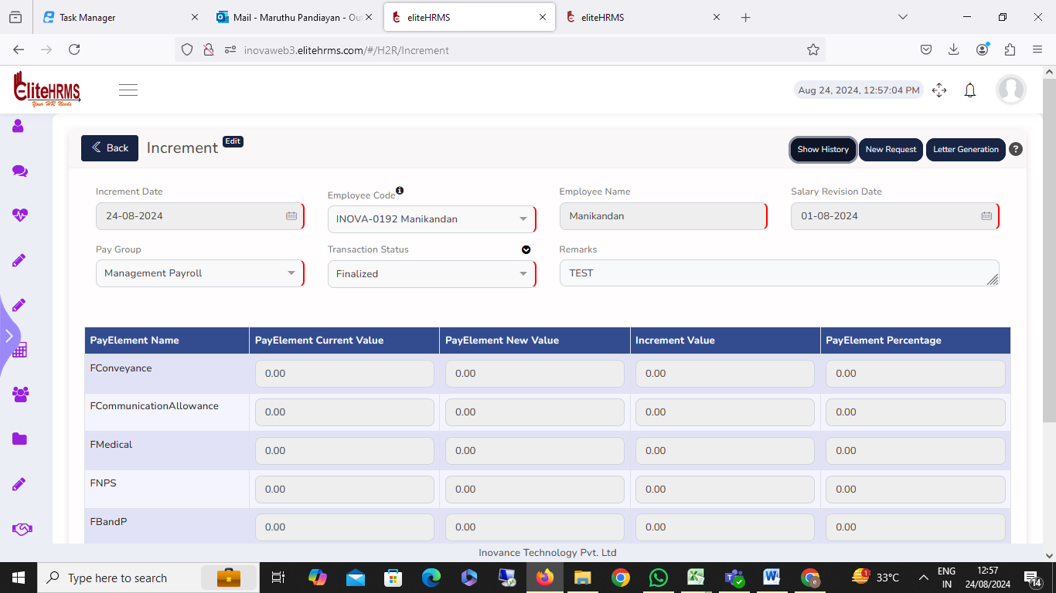

48. Promotion
I have checked the Promotion Entry details data satisfactory message, but the problem is the letter-generated options click showing for the error message. Please check
Status: Pending

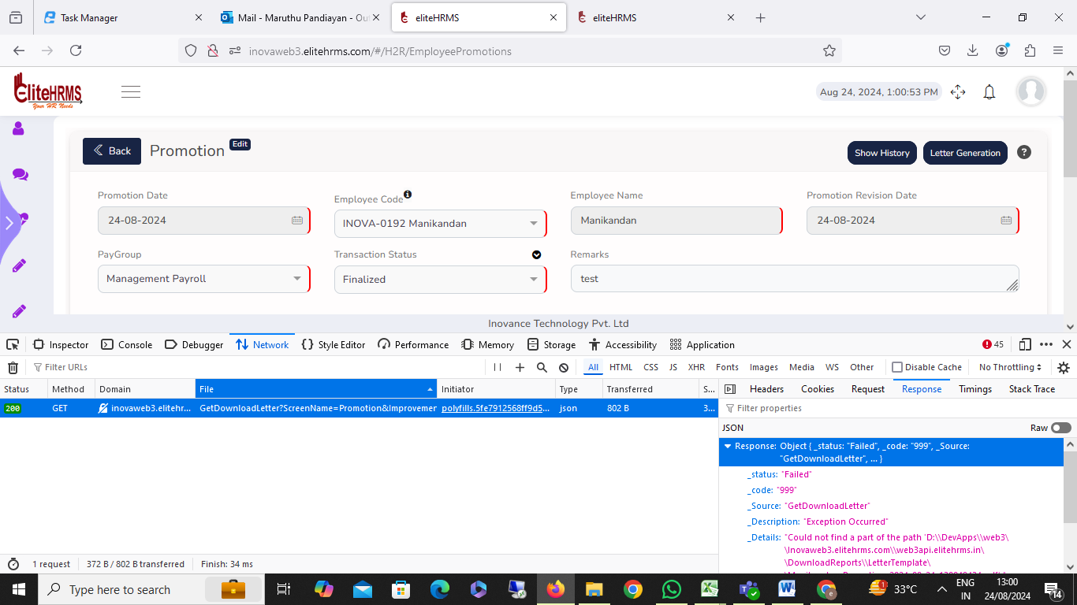

49. Employee details letter:
Status:Pending

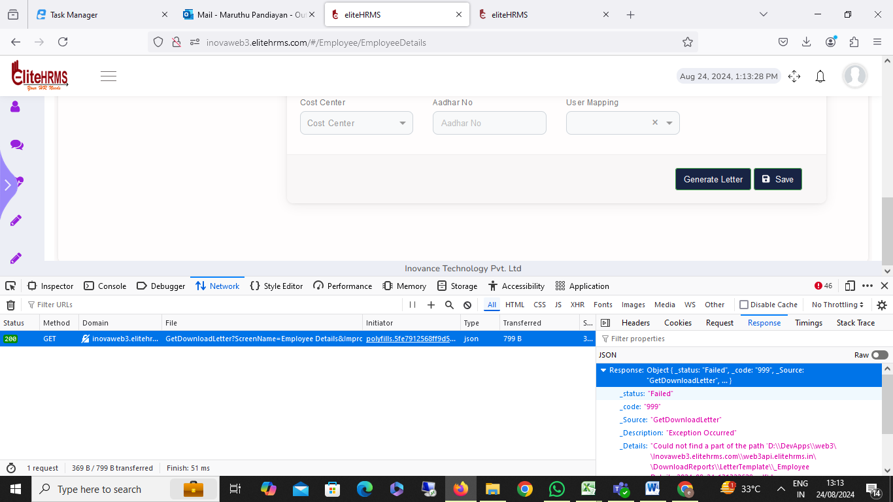

50. Employee Separation:
I have checked the Employee Separation details data satisfactory message, but the problem is the letter-generated options click showing for the error message. Please check
Status: Pending

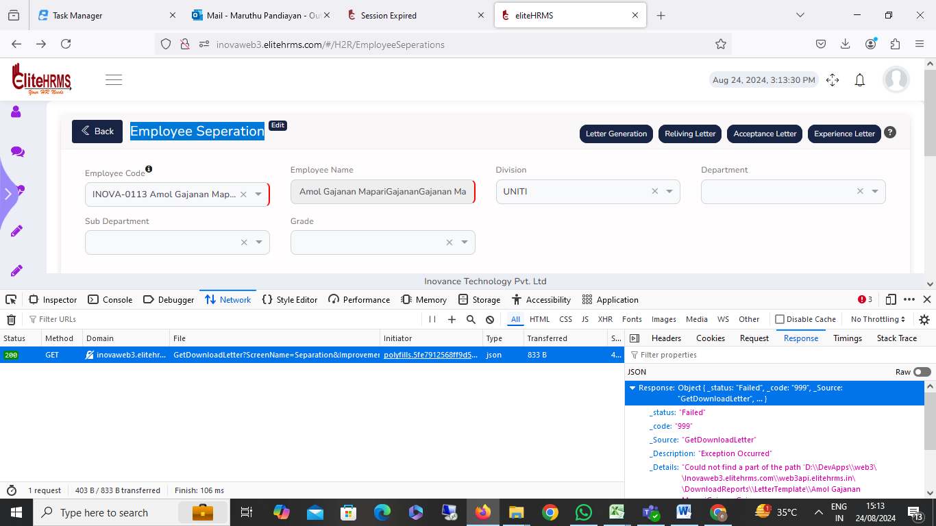

51. Employee Separation
Status : Pending
Reliving letter, Acceptance, and Experience button not working, Please check

52. Employee Separation:

Once the separation entry is deleted but employee details have not changed status, please check the issue.
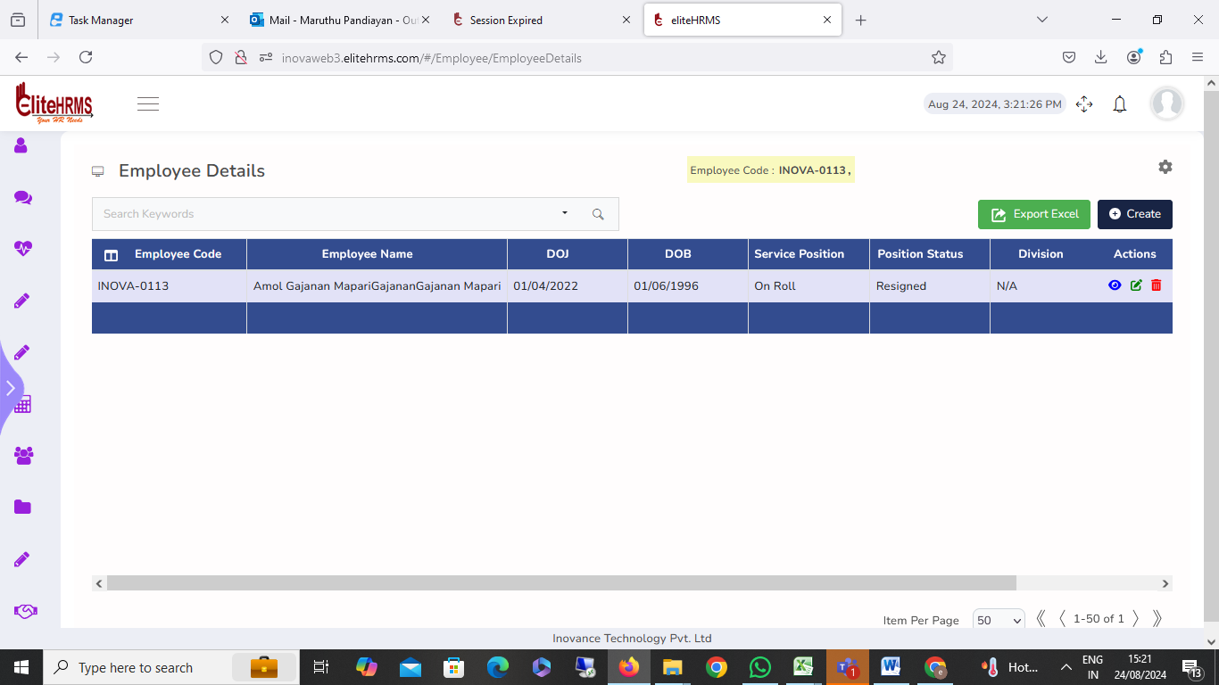
53. Intra Transfer

1. I have checked intra details data satisfactory message, but the problem is the letter-generated options click showing for the not working.
2. I have changed the intra-transfer role details, which are working fine, but the problem is that the changed details of employee’s master details are not updated. Please check.
Status: Pending

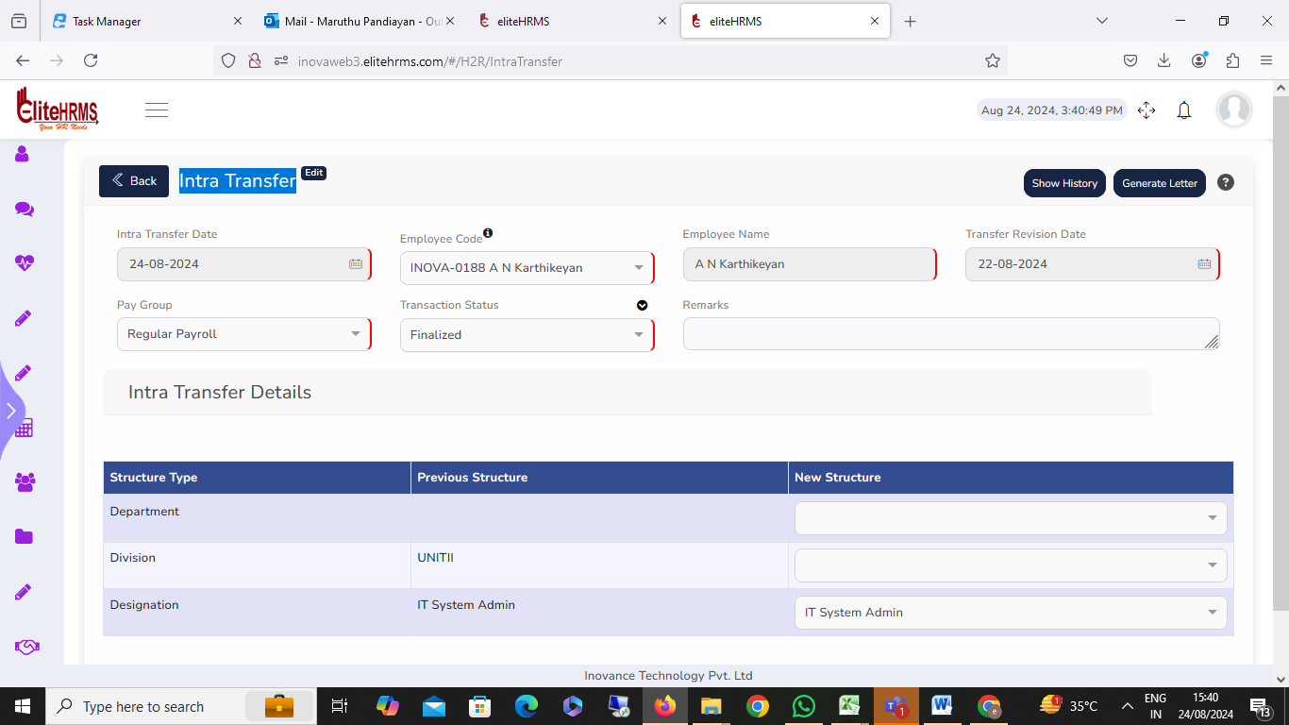

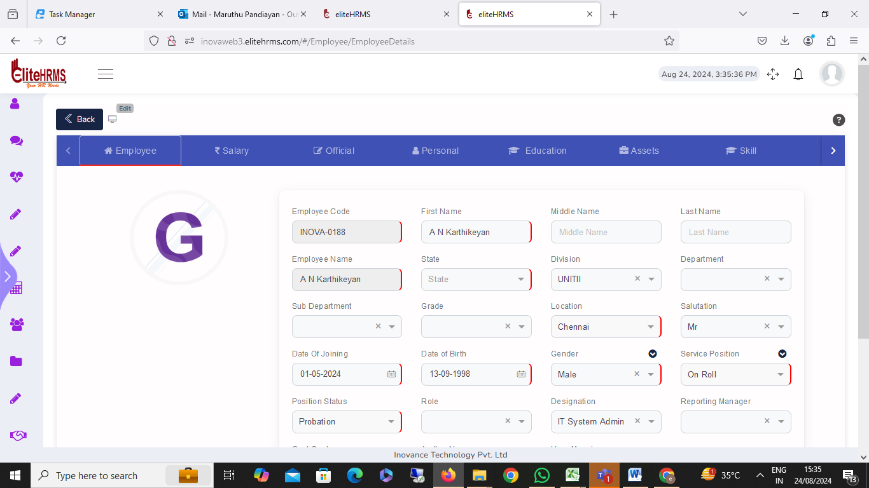

54. CCC Extension

I have changed the CCC Extension service position details, which are working fine, but the problem is that the changed details of employee’s master details are not updated. Please check.
I have checked intra details data satisfactory message, but the problem is the letter-generated options click showing for the not working.
Status: Pending

55. Review Job Offer:

Job offer information is available in the data; however, when viewing the job offer report, the data that is available does not appear. Kindly verify.
Status: Completed

56. Review Increments:

The Review Increments report search button clicks on multiple records shown on the screen and also report; transaction details are only available in two records. Please check the issue.
Status: Completed

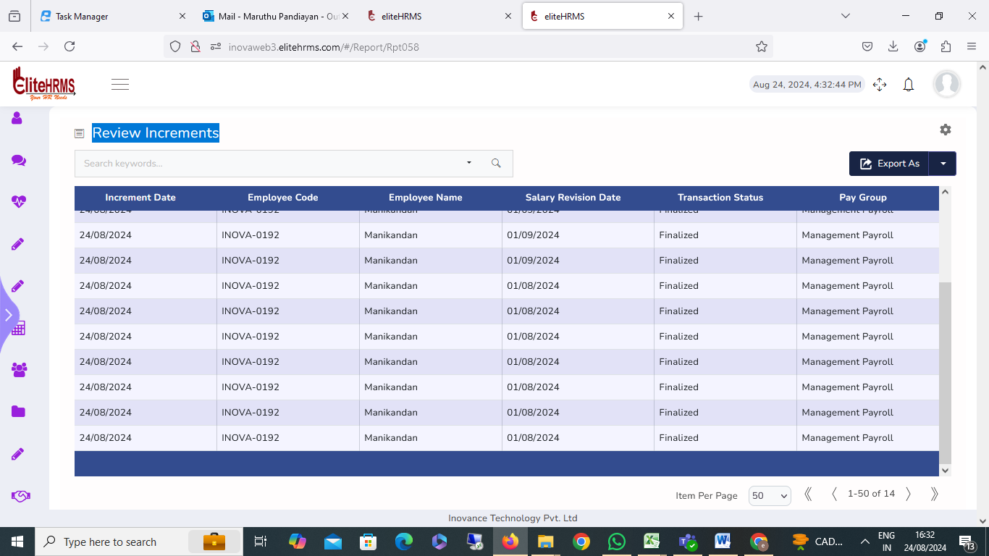

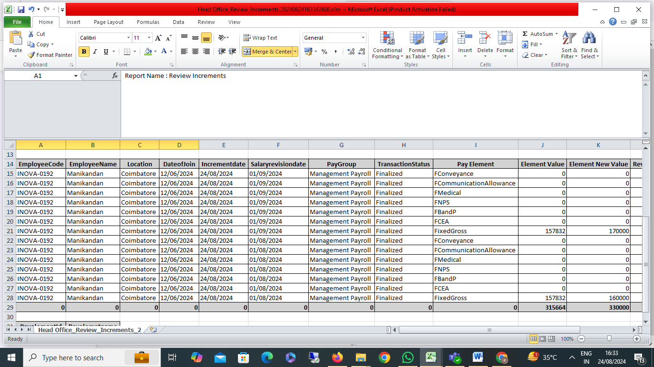

57. Review Promotion:

The Review Promotion report search button clicks on multiple records shown on the screen and also reports; transaction details are only available in one record. Please check the issue.
Status: Pending

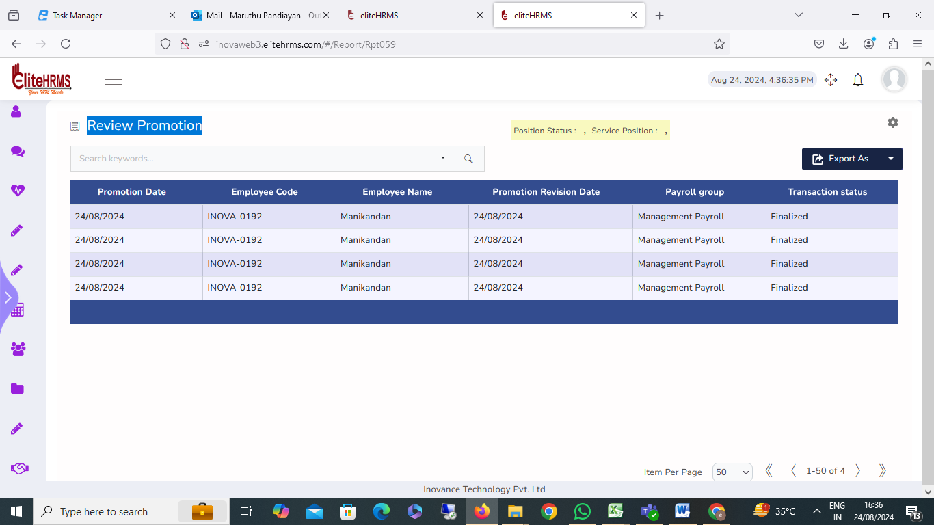

58. Review Location Transfer:
Status: Pending

The Review Location Transfer report all column filter options are not working. Please check.
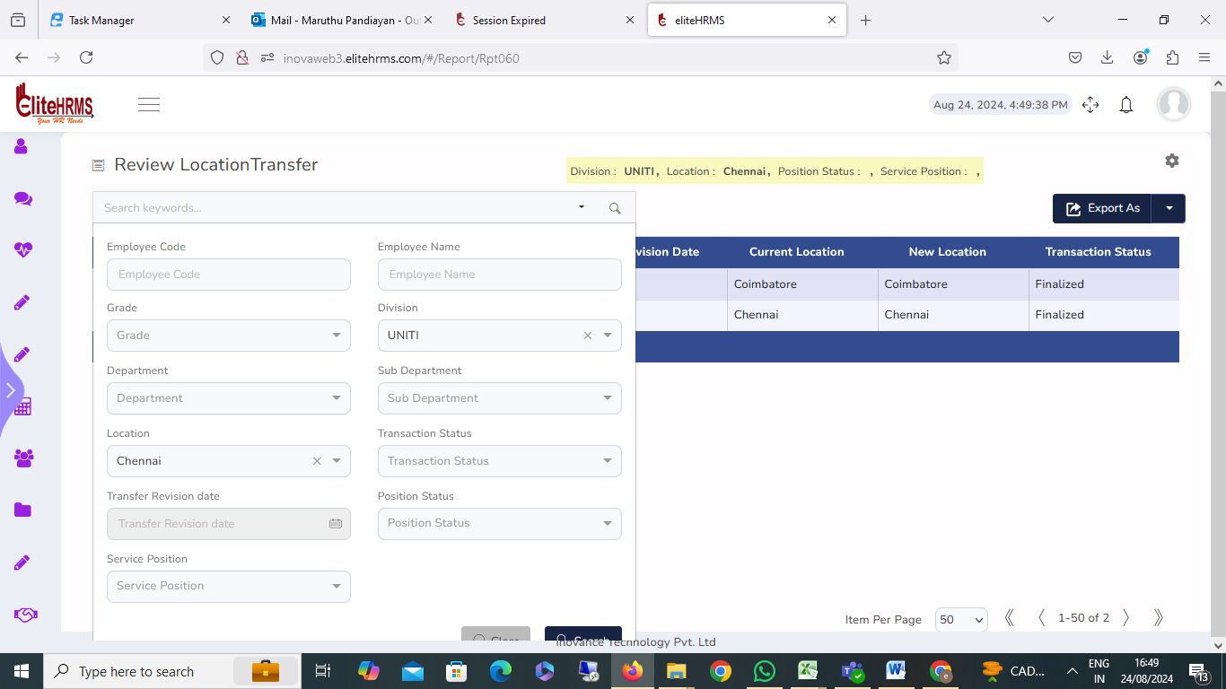

59. Review Intra Transfer:
Status: Pending

The Review Intra Transfer report search button clicks on multiple records shown on the screen and also report; transaction details are only available in one record. Please check the issue.

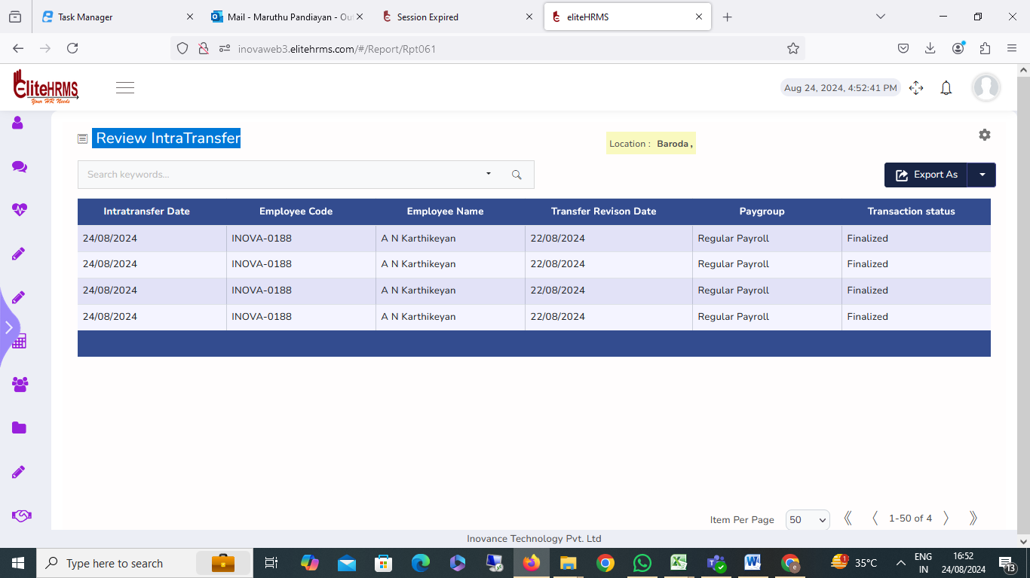

60. Review CCCExtention:

Review the CCC Extension report and select the column report issue. Please check.

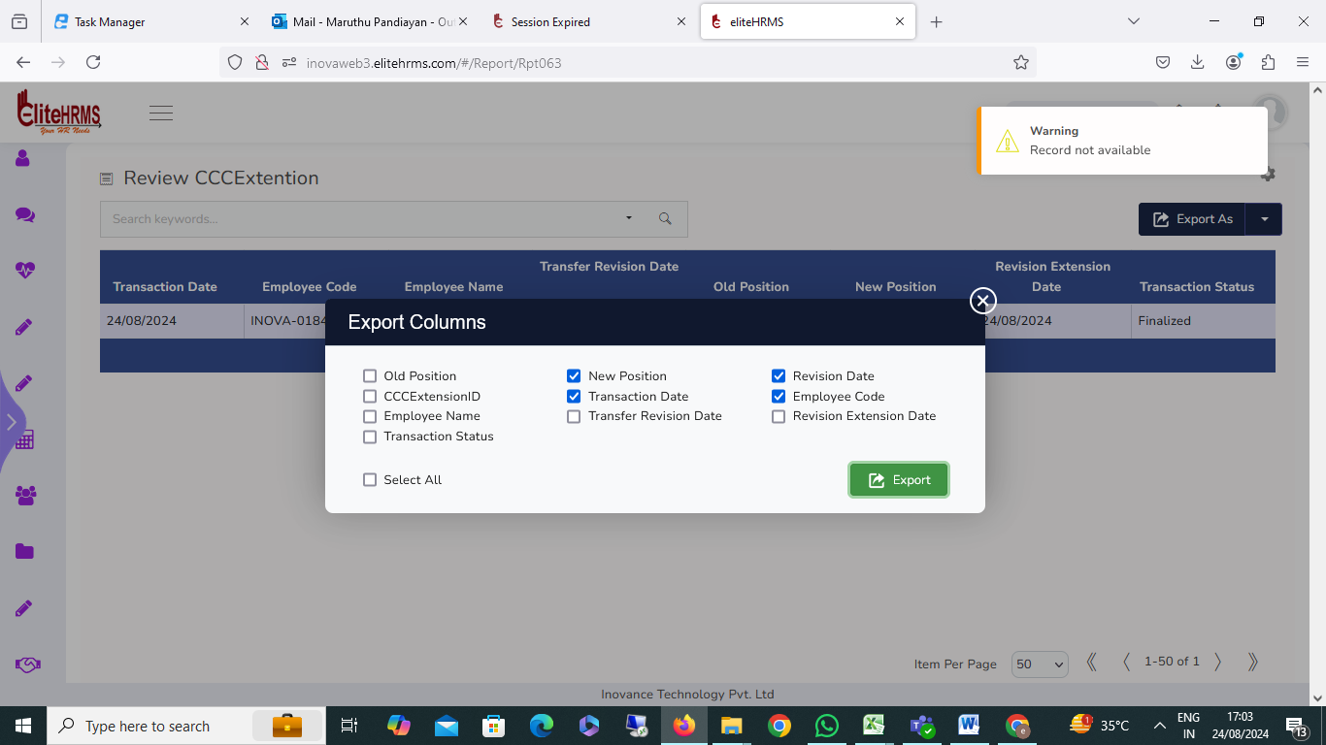

61. Review Hold Payroll
Review Hold Payroll status details are not visible.

Status: Pending

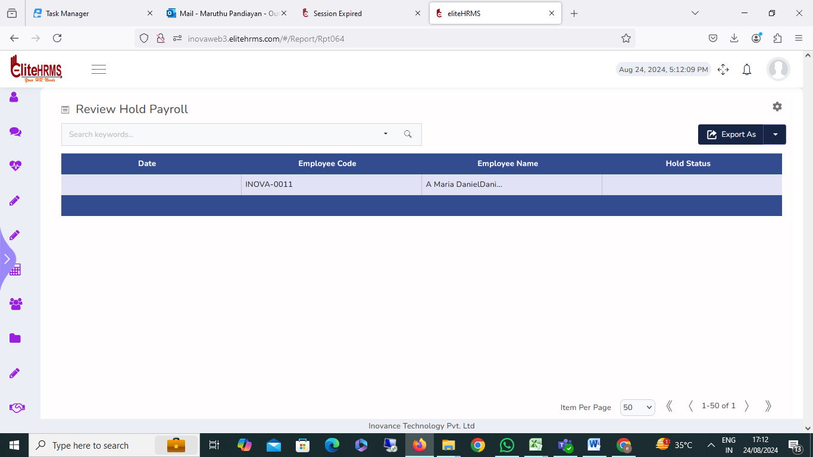

62.LWF:
Status: Pending

The Labor Welfare Fund selected the state name shown for the error message; please check.
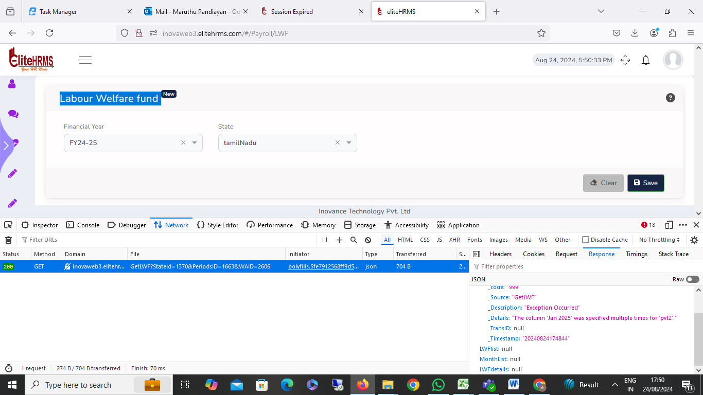

63. Professional Tax:

The Professional Tax selected the state name shown for the error message; please check.

Status: Pending
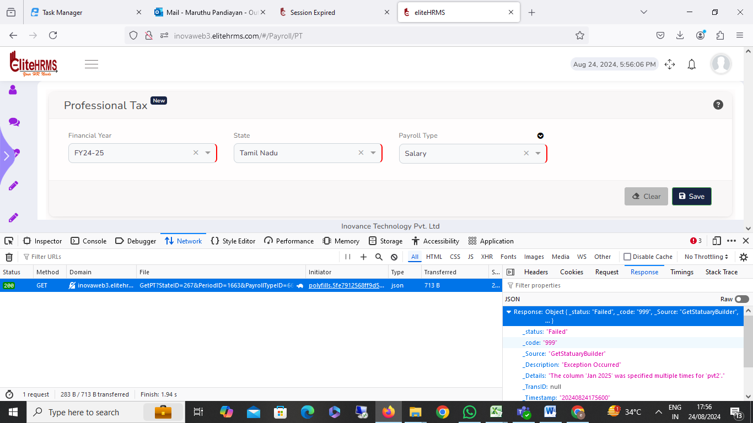

64. Single Employee Payroll Process:
Status: Pending

The Single Employee Payroll Process period is not showing details and is not visible.

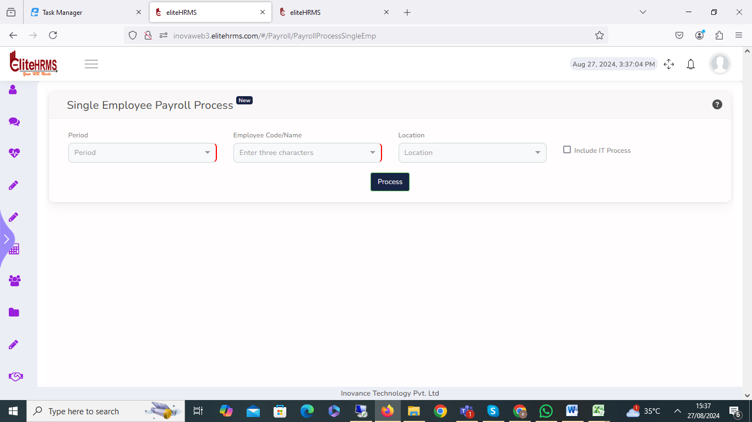

65.PF ECR :

The report details and is not visible.

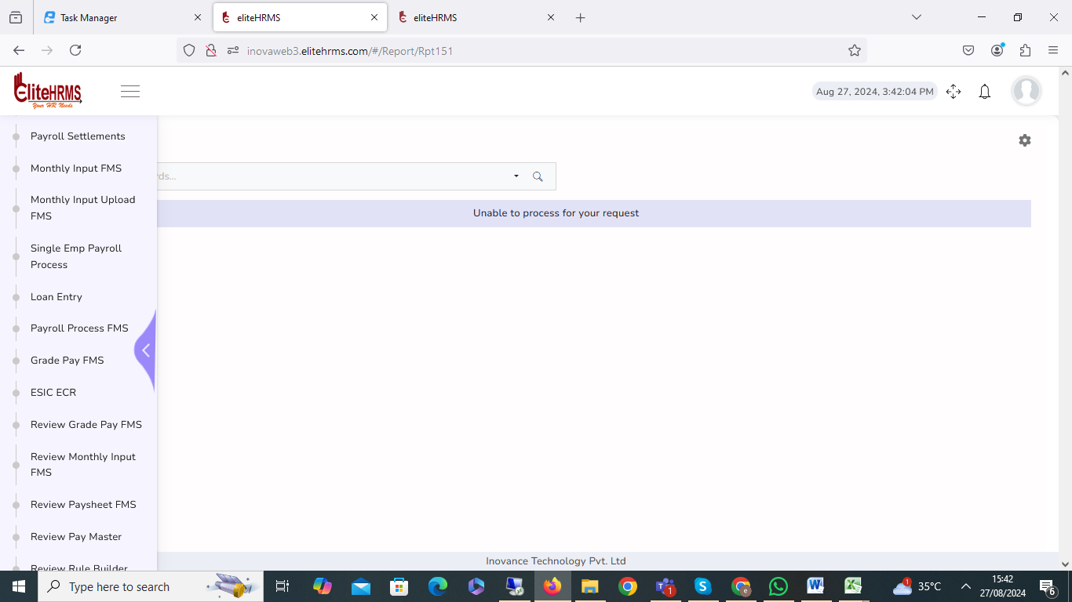
66. Review Employee PT:
Status: Pending

Review the Review Pt Report. Select column details that are not visible. Please check the issue.

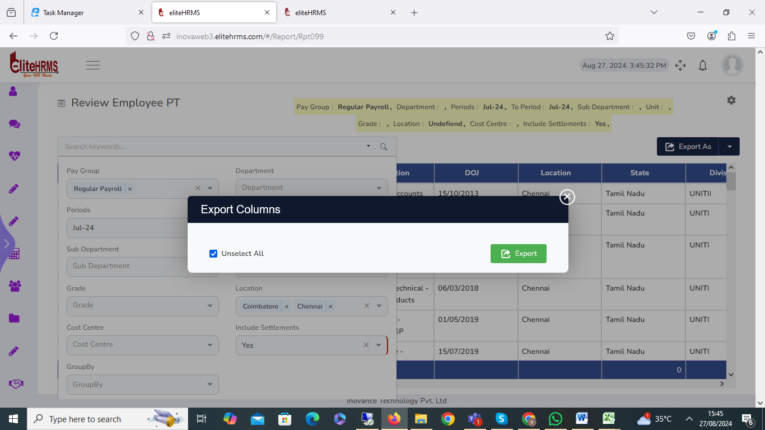

67. Payroll Monthly Differentiation:
Status: Pending

The Payroll Monthly Differentiation period is not showing details and is not visible.

Status: Pending

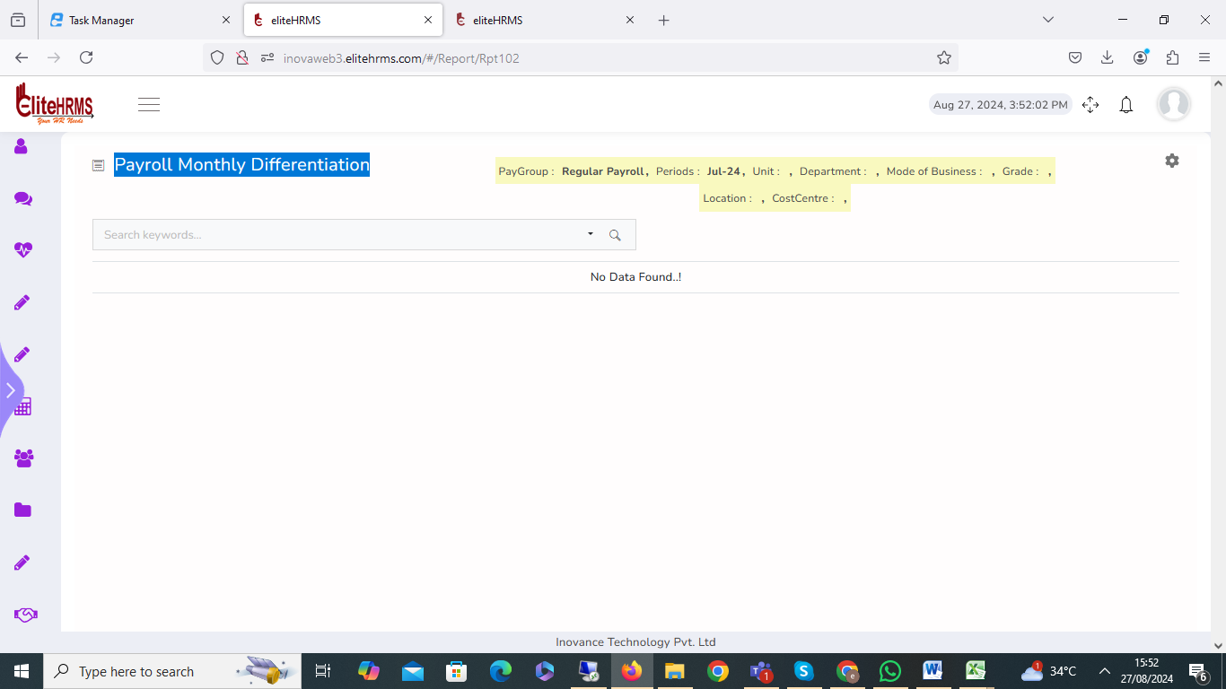
68. Review Annual Summary
Review the Review Annual Summary. Select column details that are not visible. Please check the issue.
Status: Pending

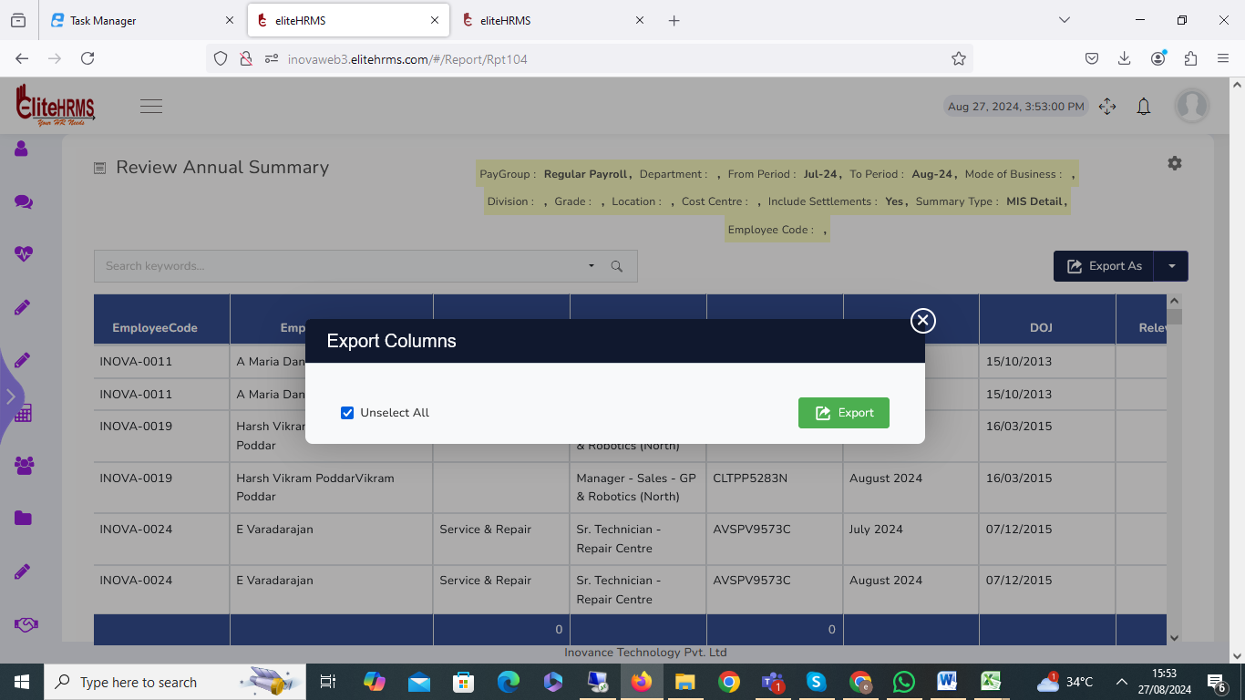

69. Review PF UAN Genration:
Review the Review Annual Summary. Select column details that are not visible. Please check the issue.
Status: Pending

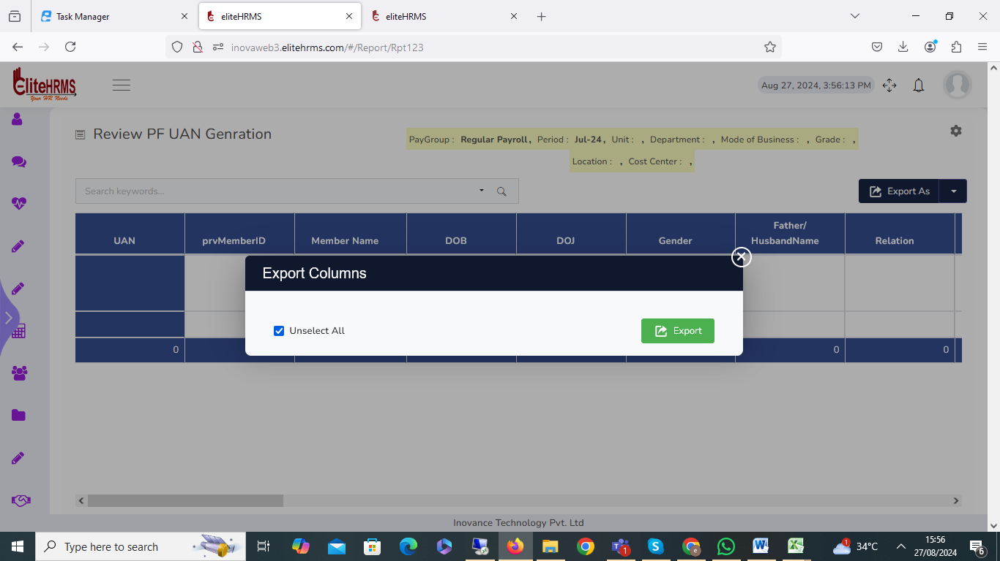

70. Review Loan Balance DRA:

The Review Loan Balance DRA search button clicks on multiple records shown on the screen and also reports; transaction details are only available in Two records. Please check the issue.
Status: Pending

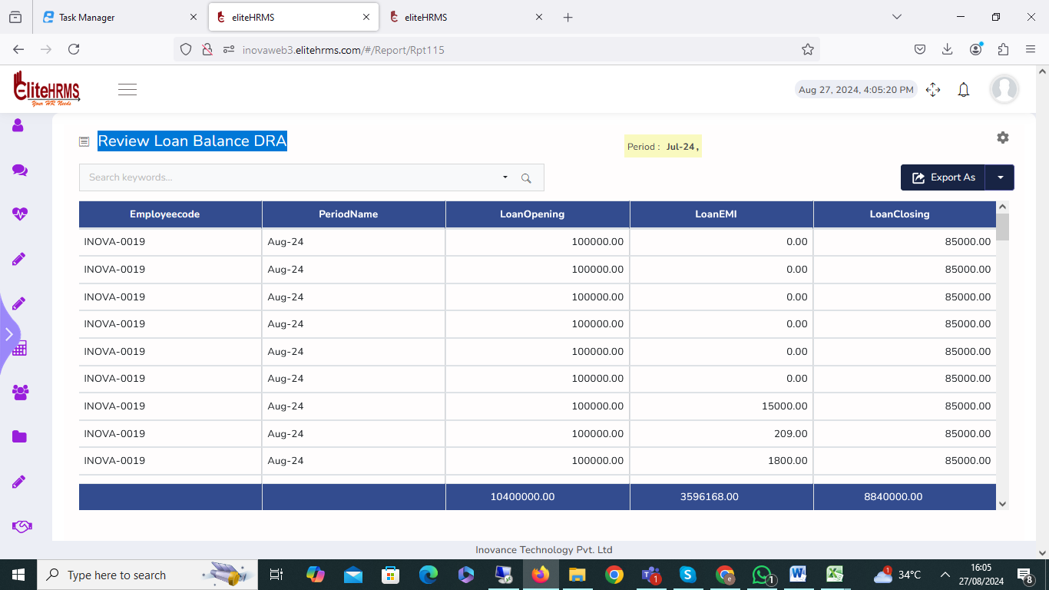

71 Common > User:

- I have created a new user, but the error message is record as already exiting. Please check the error.
- I have modified the email adders display error message showed. Please check.

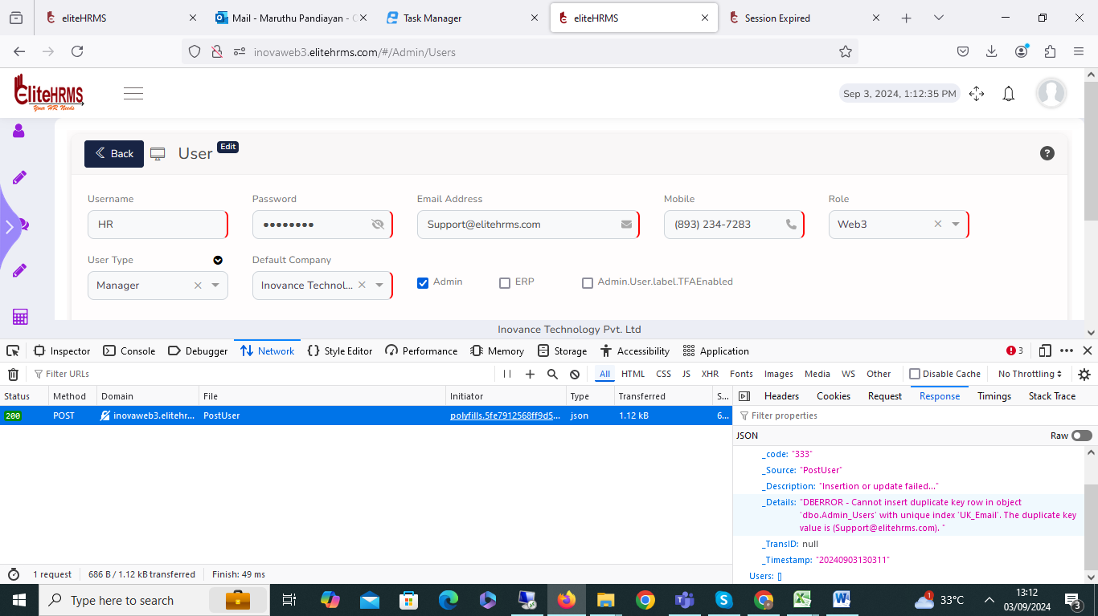

72. Employee details> Employee Information:

I have added the one relationship details, then I will resolve, but the delete button is not working.

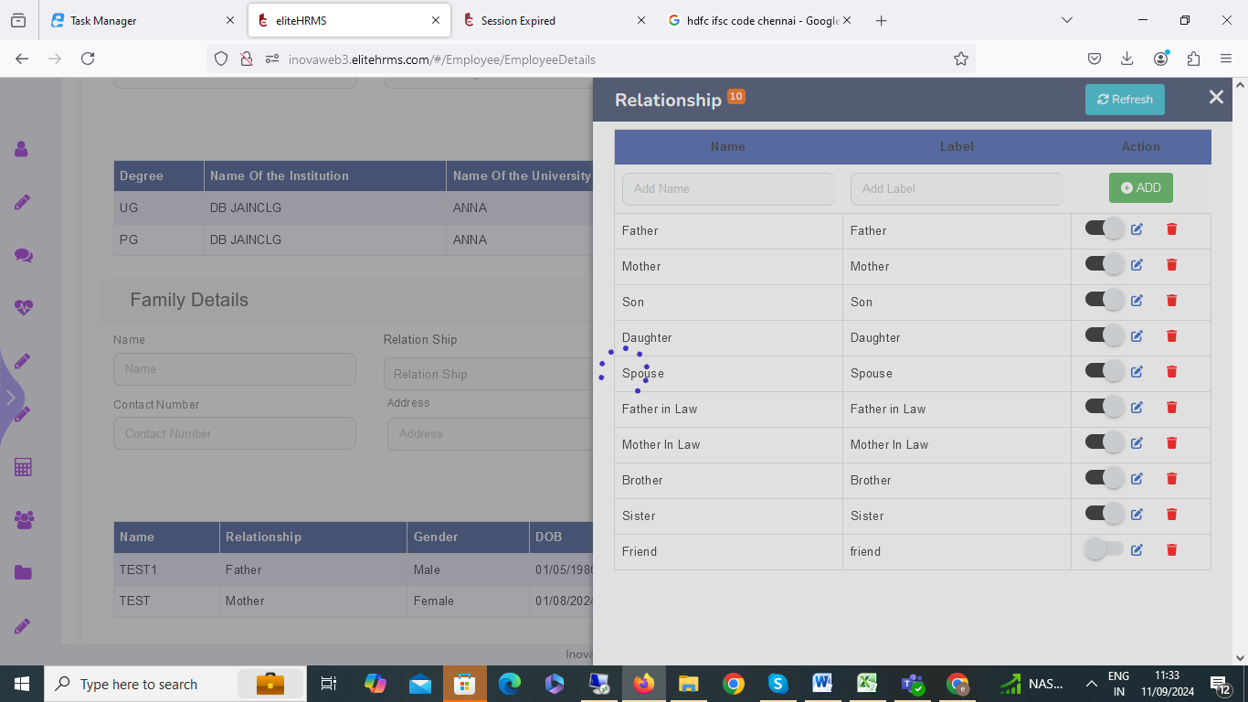

73. Employee> Employee Information:

I have added the family and education and finally removed them, but I finally saved the button and clicked show to error message.
Status: Pending

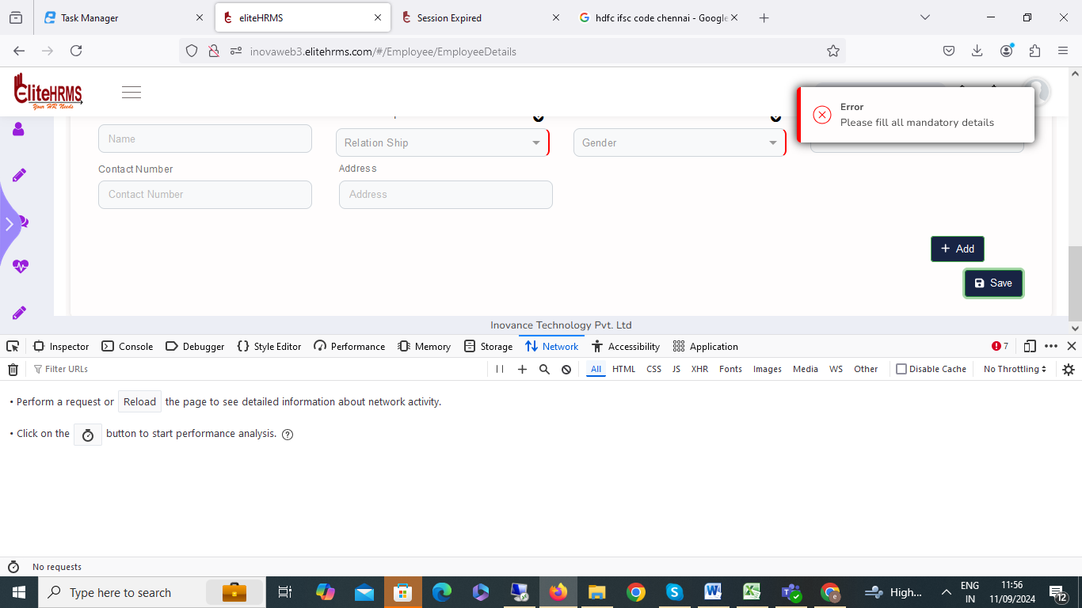

74. Increment
Status: Pending

I have entry data, finally checked, and finally saved button, click error message, show please check.

